Gestiunea competitiei Esports League of Legends

Hutan Mihai-Alexandru

Grupa 243

Cuprins

1. Utilitatea bazei de date 2

2. Diagrama Entitate-Relatie 4

3. Diagrama Conceptuala 5

4. Definirea tabelelor si a constrangerilor 6

5. Inserarea datelor 8

6. Subprogram stocat cu minim doua tipuri de colectii 31

7. Subprogram stocat cu doua tipuri de cursoare 33

8. Subprogram stocat de tip functie cu 3 tabele intr-o singura comanda si minim doua exceptii definite 34

9. Subprogram stocat cu 5 tabele intr-o singura comanda si exceptiile no_data_found si too_many_rows tratate 39

10. Trigger de tip LMD la nivel de comanda 41

11. Trigger de tip LMD la nivel de linie 42

12. Trigger de tip LDD 43

13. Pachet cu obiectele realizate in cadrul proiectului 44

14. Pachet cu flux de actiuni 51

## Utilitatea bazei de date

Baza de date contine informatii cu privire la turneele competitiei Esports League of Legends, meciurile jucate in cadrul acestora, echipele participante, jucatorii si statistici legate de acestia, campionii jucati cat si cei banati.

Scopul crearii acestei baze de date este de a facilita generarea de statistici, ce ulterior vor fi analizate in cadrul evenimentelor de catre casteri in timpul pauzelor.

Aceasta competitie are un numar mare de turnee an de an. Fiecare turneu contine informatii relevante precum numele, data inceperii, data terminarii si locatia unde are loc acesta.

In cadrul fiecarui turneu au loc mai multe meciuri la care participa doua echipe, si se desfasoara intr-o data bine stabilita. In mod evident trebuie sa retinem si rezultatele acestor meciuri pentru generarea viitoarelor statistici.

In cadrul jocului League of Legends serverele sunt distribuite in urmatoarele regiuni: “NA” – North America, “EU” – Europe, “KR” – Korea, “AS” – Asia, “TUR” – Turkey. Aceste regiuni sunt date specifice atat jucatorilor cat si echipelor, aratand zona de provenienta a acestora.

Fiecare echipa are un nume si apartine unei regiuni, iar in cadrul fiecarei echipe avem 5 jucatori ce au un nume, un prenume, un nume de joc cat si un rol.

Rolurile bine cunoscute ale acestui joc sunt in numar de 5 si sunt urmatoarele: “Top”, “Jungle”, “Mid”, “ADC”, “Support”.

Pentru fiecare meci jucat de catre o echipa, pentru toti jucatorii acesteia vom salva date despre cate kill-uri, death-uri, assist-uri si creep score au acestia in respectivul meci.

Fiecare jucator trebuie sa joace cate un campion in cadrul fiecarui meci, iar despre campioni stim numele acestora, cat si rolul specific al acestora (un jucator cu rolul x nu trebuie neaparat sa joace un campion cu rolul x, dar este incurajat de catre sensul jocului). De asemenea in cadrul fiecarui meci exista si sectiunea de ban-uri in care unii campioni sunt blocati din a fi alesi de catre jucatorii celor doua echipe participante.

## Diagrama Entitate-Relatie

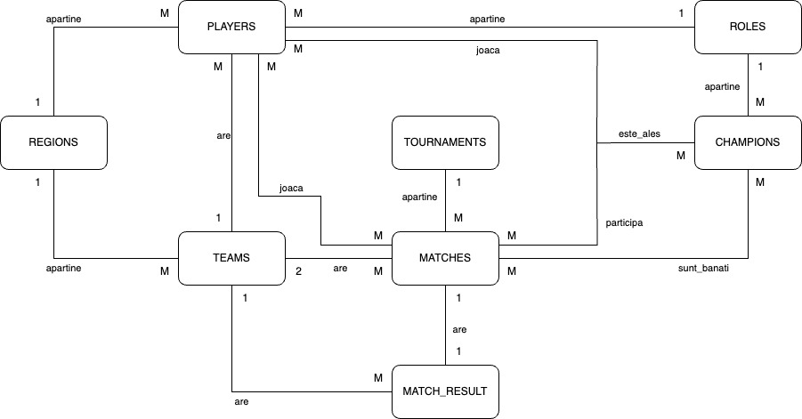

## Diagrama Conceptuala

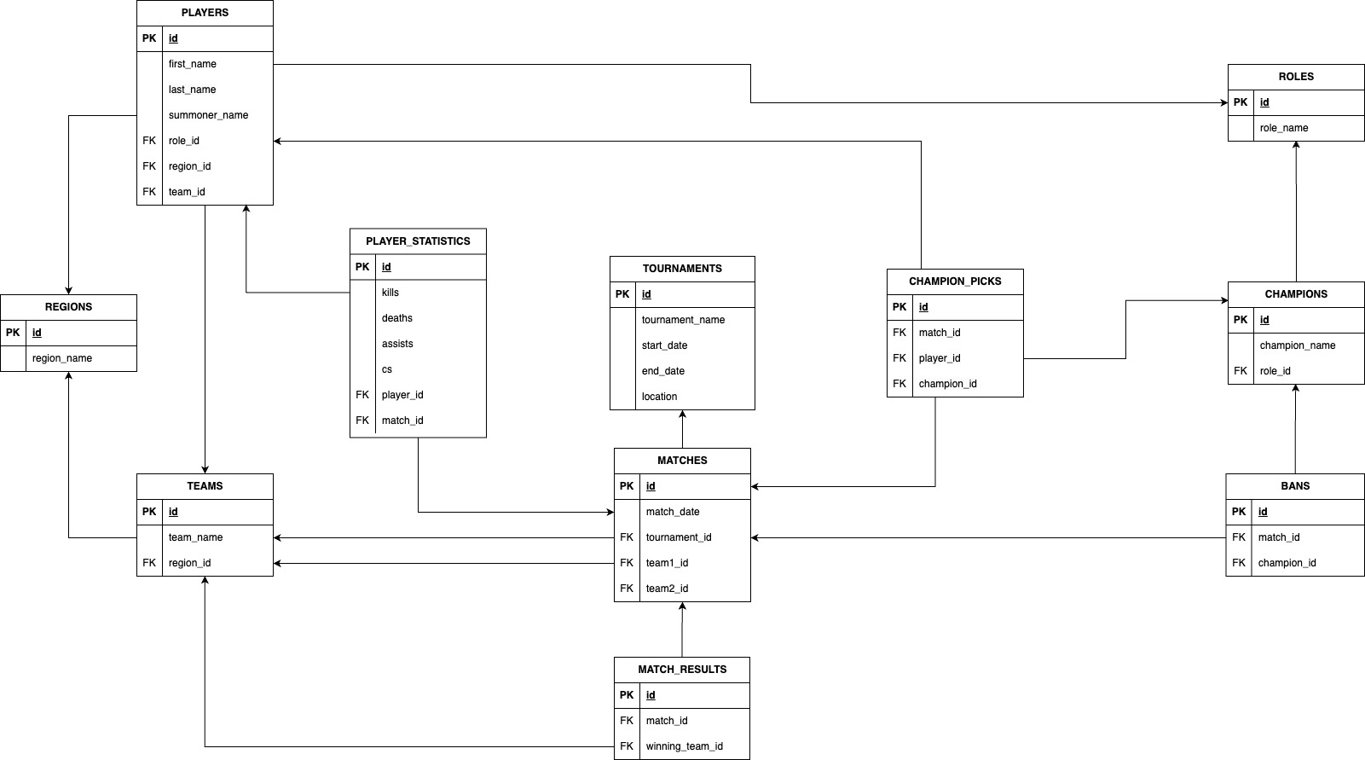

## Definirea tabelelor si a constrangerilor

*CREATE TABLE* regions  
(  
 *id NUMBER GENERATED BY DEFAULT ON NULL AS IDENTITY*,  
 region_name *VARCHAR2*(3) *NOT NULL*,  
 *PRIMARY KEY* (*id*)  
);  
  
*CREATE TABLE* teams  
(  
 *id NUMBER GENERATED BY DEFAULT ON NULL AS IDENTITY*,  
 team_name *VARCHAR2*(100) *NOT NULL*,  
 region_id *NUMBER NOT NULL*,  
 *PRIMARY KEY* (*id*),  
 *FOREIGN KEY* (region_id) *REFERENCES* regions (*id*)  
);  
  
*CREATE TABLE roles*(  
 *id NUMBER GENERATED BY DEFAULT ON NULL AS IDENTITY*,  
 role_name *VARCHAR2*(15) *NOT NULL*,  
 *PRIMARY KEY* (*id*)  
);  
  
*CREATE TABLE* players  
(  
 *id NUMBER GENERATED BY DEFAULT ON NULL AS IDENTITY*,  
 first_name *VARCHAR2*(50) *NOT NULL*,  
 last_name *VARCHAR2*(50) *NOT NULL*,  
 summoner_name *VARCHAR2*(50) *NOT NULL*,  
 role_id *NUMBER NOT NULL*,  
 region_id *NUMBER NOT NULL*,  
 team_id *NUMBER NOT NULL*,  
 *PRIMARY KEY* (*id*),  
 *FOREIGN KEY* (role_id) *REFERENCES roles* (*id*),  
 *FOREIGN KEY* (region_id) *REFERENCES* regions (*id*),  
 *FOREIGN KEY* (team_id) *REFERENCES* teams (*id*)  
);  
  
*CREATE TABLE* tournaments  
(  
 *id NUMBER GENERATED BY DEFAULT ON NULL AS IDENTITY*,  
 tournament_name *VARCHAR2*(100) *NOT NULL*,  
 start_date *DATE NOT NULL*,  
 end_date *DATE NOT NULL*,  
 *location VARCHAR2*(100) *NOT NULL*,  
 *PRIMARY KEY* (*id*)  
);  
  
*CREATE TABLE* matches  
(  
 *id NUMBER GENERATED BY DEFAULT ON NULL AS IDENTITY*,  
 tournament_id *NUMBER NOT NULL*,  
 team1_id *NUMBER NOT NULL*,  
 team2_id *NUMBER NOT NULL*,  
 match_date *DATE NOT NULL*,  
 *PRIMARY KEY* (*id*),  
 *FOREIGN KEY* (tournament_id) *REFERENCES* tournaments (*id*),  
 *FOREIGN KEY* (team1_id) *REFERENCES* teams (*id*),  
 *FOREIGN KEY* (team2_id) *REFERENCES* teams (*id*)  
);  
  
*CREATE TABLE* match_results  
(  
 *id NUMBER GENERATED BY DEFAULT ON NULL AS IDENTITY*,  
 match_id *NUMBER NOT NULL*,  
 winning_team_id *NUMBER NOT NULL*,  
 *PRIMARY KEY* (*id*),  
 *FOREIGN KEY* (match_id) *REFERENCES* matches (*id*),  
 *FOREIGN KEY* (winning_team_id) *REFERENCES* teams (*id*),  
 *UNIQUE* (match_id)  
);  
  
*CREATE TABLE* player_statistics  
(  
 *id NUMBER GENERATED BY DEFAULT ON NULL AS IDENTITY*,  
 player_id *NUMBER NOT NULL*,  
 match_id *NUMBER NOT NULL*,  
 kills *NUMBER NOT NULL*,  
 deaths *NUMBER NOT NULL*,  
 assists *NUMBER NOT NULL*,  
 cs *NUMBER NOT NULL*,  
 *PRIMARY KEY* (*id*),  
 *FOREIGN KEY* (player_id) *REFERENCES* players (*id*),  
 *FOREIGN KEY* (match_id) *REFERENCES* matches (*id*),  
 *UNIQUE* (player_id, match_id)  
);  
  
*CREATE TABLE* champions  
(  
 *id NUMBER GENERATED BY DEFAULT ON NULL AS IDENTITY*,  
 champion_name *VARCHAR2*(50) *NOT NULL*,  
 role_id *NUMBER NOT NULL*,  
 *PRIMARY KEY* (*id*),  
 *FOREIGN KEY* (role_id) *REFERENCES roles* (*id*)  
);  
  
*CREATE TABLE* champion_picks  
(  
 *id NUMBER GENERATED BY DEFAULT ON NULL AS IDENTITY*,  
 match_id *NUMBER NOT NULL*,  
 player_id *NUMBER NOT NULL*,  
 champion_id *NUMBER NOT NULL*,  
 *PRIMARY KEY* (*id*),  
 *FOREIGN KEY* (match_id) *REFERENCES* matches (*id*),  
 *FOREIGN KEY* (player_id) *REFERENCES* players (*id*),  
 *FOREIGN KEY* (champion_id) *REFERENCES* champions (*id*),  
 *UNIQUE* (match_id, player_id)  
);  
  
*CREATE TABLE* bans  
(  
 *id NUMBER GENERATED BY DEFAULT ON NULL AS IDENTITY*,  
 match_id *NUMBER NOT NULL*,  
 champion_id *NUMBER NOT NULL*,  
 *PRIMARY KEY* (*id*),  
 *FOREIGN KEY* (match_id) *REFERENCES* matches (*id*),  
 *FOREIGN KEY* (champion_id) *REFERENCES* champions (*id*),  
 *UNIQUE* (match_id, champion_id)  
);

## Inserarea datelor

-- Regions  
*INSERT INTO* regions (region_name)  
*VALUES* ('NA');  
*INSERT INTO* regions (region_name)  
*VALUES* ('EU');  
*INSERT INTO* regions (region_name)  
*VALUES* ('KR');  
*INSERT INTO* regions (region_name)  
*VALUES* ('AS');  
*INSERT INTO* regions (region_name)  
*VALUES* ('TUR');  
*COMMIT*;  
  
-- Teams  
*INSERT INTO* teams (team_name, region_id)  
*VALUES* ('TSM', 1);  
*INSERT INTO* teams (team_name, region_id)  
*VALUES* ('Fnatic', 2);  
*INSERT INTO* teams (team_name, region_id)  
*VALUES* ('SK Telecom T1', 3);  
*INSERT INTO* teams (team_name, region_id)  
*VALUES* ('EDward Gaming', 4);  
*INSERT INTO* teams (team_name, region_id)  
*VALUES* ('Royal Never Give Up', 4);  
*COMMIT*;  
  
-- Roles  
*INSERT INTO roles* (role_name)  
*VALUES* ('Top');  
*INSERT INTO roles* (role_name)  
*VALUES* ('Jungle');  
*INSERT INTO roles* (role_name)  
*VALUES* ('Mid');  
*INSERT INTO roles* (role_name)  
*VALUES* ('ADC');  
*INSERT INTO roles* (role_name)  
*VALUES* ('Support');  
*COMMIT*;  
  
-- Players  
-- Players for TSM (Team SoloMid)  
*INSERT INTO* players (first_name, last_name, summoner_name, role_id, region_id, team_id)  
*VALUES* ('Søren', 'Bjerg', 'Bjergsen', 3, 1, 1);  
*INSERT INTO* players (first_name, last_name, summoner_name, role_id, region_id, team_id)  
*VALUES* ('Mingyi', 'Shen', 'Spica', 2, 1, 1);  
*INSERT INTO* players (first_name, last_name, summoner_name, role_id, region_id, team_id)  
*VALUES* ('Heo', 'Seung-hoon', 'Huni', 1, 1, 1);  
*INSERT INTO* players (first_name, last_name, summoner_name, role_id, region_id, team_id)  
*VALUES* ('Yiliang', 'Peng', 'Doublelift', 4, 1, 1);  
*INSERT INTO* players (first_name, last_name, summoner_name, role_id, region_id, team_id)  
*VALUES* ('Vincent', 'Wang', 'Biofrost', 5, 1, 1);  
*COMMIT*;  
  
-- Players for Fnatic  
*INSERT INTO* players (first_name, last_name, summoner_name, role_id, region_id, team_id)  
*VALUES* ('Gabriël', 'Rau', 'Bwipo', 1, 2, 2);  
*INSERT INTO* players (first_name, last_name, summoner_name, role_id, region_id, team_id)  
*VALUES* ('Oskar', 'Boderek', 'Selfmade', 2, 2, 2);  
*INSERT INTO* players (first_name, last_name, summoner_name, role_id, region_id, team_id)  
*VALUES* ('Tim', 'Lipovšek', 'Nemesis', 3, 2, 2);  
*INSERT INTO* players (first_name, last_name, summoner_name, role_id, region_id, team_id)  
*VALUES* ('Martin', 'Larsson', 'Rekkles', 4, 2, 2);  
*INSERT INTO* players (first_name, last_name, summoner_name, role_id, region_id, team_id)  
*VALUES* ('Zdravets', 'Galabov', 'Hylissang', 5, 2, 2);  
*COMMIT*;  
  
-- Players for SK Telecom T1  
*INSERT INTO* players (first_name, last_name, summoner_name, role_id, region_id, team_id)  
*VALUES* ('Kim', 'Dong-ha', 'Khan', 1, 3, 3);  
*INSERT INTO* players (first_name, last_name, summoner_name, role_id, region_id, team_id)  
*VALUES* ('Moon', 'Woo-chan', 'Cuzz', 2, 3, 3);  
*INSERT INTO* players (first_name, last_name, summoner_name, role_id, region_id, team_id)  
*VALUES* ('Lee', 'Sang-hyeok', 'Faker', 3, 3, 3);  
*INSERT INTO* players (first_name, last_name, summoner_name, role_id, region_id, team_id)  
*VALUES* ('Park', 'Jong-ik', 'Teddy', 4, 3, 3);  
*INSERT INTO* players (first_name, last_name, summoner_name, role_id, region_id, team_id)  
*VALUES* ('Lee', 'Jae-wan', 'Effort', 5, 3, 3);  
*COMMIT*;  
  
-- Players for EDward Gaming  
*INSERT INTO* players (first_name, last_name, summoner_name, role_id, region_id, team_id)  
*VALUES* ('Li', 'Jian', 'Flandre', 1, 4, 4);  
*INSERT INTO* players (first_name, last_name, summoner_name, role_id, region_id, team_id)  
*VALUES* ('Ming', 'Kai', 'Clearlove', 2, 4, 4);  
*INSERT INTO* players (first_name, last_name, summoner_name, role_id, region_id, team_id)  
*VALUES* ('Lee', 'Yeon-jae', 'Scout', 3, 4, 4);  
*INSERT INTO* players (first_name, last_name, summoner_name, role_id, region_id, team_id)  
*VALUES* ('Hu', 'Xian-zhao', 'iBoy', 4, 4, 4);  
*INSERT INTO* players (first_name, last_name, summoner_name, role_id, region_id, team_id)  
*VALUES* ('Tian', 'Xin', 'Meiko', 5, 4, 4);  
*COMMIT*;  
  
-- Players for Royal Never Give Up  
*INSERT INTO* players (first_name, last_name, summoner_name, role_id, region_id, team_id)  
*VALUES* ('Yan', 'Jun-ze', 'Letme', 1, 4, 5);  
*INSERT INTO* players (first_name, last_name, summoner_name, role_id, region_id, team_id)  
*VALUES* ('Hung', 'Hau-Hsuan', 'Karsa', 2, 4, 5);  
*INSERT INTO* players (first_name, last_name, summoner_name, role_id, region_id, team_id)  
*VALUES* ('Li', 'Yuan-Hao', 'Xiaohu', 3, 4, 5);  
*INSERT INTO* players (first_name, last_name, summoner_name, role_id, region_id, team_id)  
*VALUES* ('Jian', 'Zi-Hao', 'Uzi', 4, 4, 5);  
*INSERT INTO* players (first_name, last_name, summoner_name, role_id, region_id, team_id)  
*VALUES* ('Shi', 'Sen-Ming', 'Ming', 5, 4, 5);  
*COMMIT*;  
  
-- Tournaments  
*INSERT INTO* tournaments (tournament_name, start_date, end_date, *location*)  
*VALUES* ('Worlds 2022', *TO_DATE*('2022-09-29', 'YYYY-MM-DD'), *TO_DATE*('2022-11-06', 'YYYY-MM-DD'), 'Tokyo');  
*INSERT INTO* tournaments (tournament_name, start_date, end_date, *location*)  
*VALUES* ('Worlds 2021', *TO_DATE*('2021-09-29', 'YYYY-MM-DD'), *TO_DATE*('2021-11-06', 'YYYY-MM-DD'), 'Berlin');  
*INSERT INTO* tournaments (tournament_name, start_date, end_date, *location*)  
*VALUES* ('Worlds 2020', *TO_DATE*('2020-09-29', 'YYYY-MM-DD'), *TO_DATE*('2020-11-06', 'YYYY-MM-DD'), 'London');  
*INSERT INTO* tournaments (tournament_name, start_date, end_date, *location*)  
*VALUES* ('Mid-Season Invitational 2022', *TO_DATE*('2022-05-09', 'YYYY-MM-DD'), *TO_DATE*('2022-05-22', 'YYYY-MM-DD'),  
 'Reykjavik');  
*INSERT INTO* tournaments (tournament_name, start_date, end_date, *location*)  
*VALUES* ('Mid-Season Invitational 2021', *TO_DATE*('2021-05-09', 'YYYY-MM-DD'), *TO_DATE*('2021-05-22', 'YYYY-MM-DD'),  
 'Stockholm');  
*COMMIT*;  
  
-- Matches  
*INSERT INTO* matches (tournament_id, team1_id, team2_id, match_date)  
*VALUES* (1, 1, 2, *TO_DATE*('2022-10-07', 'YYYY-MM-DD'));  
*INSERT INTO* matches (tournament_id, team1_id, team2_id, match_date)  
*VALUES* (1, 1, 3, *TO_DATE*('2022-10-08', 'YYYY-MM-DD'));  
*INSERT INTO* matches (tournament_id, team1_id, team2_id, match_date)  
*VALUES* (1, 1, 4, *TO_DATE*('2022-10-08', 'YYYY-MM-DD'));  
*INSERT INTO* matches (tournament_id, team1_id, team2_id, match_date)  
*VALUES* (1, 1, 5, *TO_DATE*('2022-10-09', 'YYYY-MM-DD'));  
*INSERT INTO* matches (tournament_id, team1_id, team2_id, match_date)  
*VALUES* (1, 2, 3, *TO_DATE*('2022-10-10', 'YYYY-MM-DD'));  
*INSERT INTO* matches (tournament_id, team1_id, team2_id, match_date)  
*VALUES* (1, 2, 4, *TO_DATE*('2022-10-11', 'YYYY-MM-DD'));  
*INSERT INTO* matches (tournament_id, team1_id, team2_id, match_date)  
*VALUES* (1, 2, 5, *TO_DATE*('2022-10-12', 'YYYY-MM-DD'));  
*INSERT INTO* matches (tournament_id, team1_id, team2_id, match_date)  
*VALUES* (1, 3, 4, *TO_DATE*('2022-10-13', 'YYYY-MM-DD'));  
*INSERT INTO* matches (tournament_id, team1_id, team2_id, match_date)  
*VALUES* (1, 3, 5, *TO_DATE*('2022-10-14', 'YYYY-MM-DD'));  
*INSERT INTO* matches (tournament_id, team1_id, team2_id, match_date)  
*VALUES* (1, 4, 5, *TO_DATE*('2022-10-15', 'YYYY-MM-DD'));  
*COMMIT*;  
  
-- Match Results  
*INSERT INTO* match_results (match_id, winning_team_id)  
*VALUES* (1, 1);  
*INSERT INTO* match_results (match_id, winning_team_id)  
*VALUES* (2, 1);  
*INSERT INTO* match_results (match_id, winning_team_id)  
*VALUES* (3, 1);  
*INSERT INTO* match_results (match_id, winning_team_id)  
*VALUES* (4, 1);  
*INSERT INTO* match_results (match_id, winning_team_id)  
*VALUES* (5, 2);  
*INSERT INTO* match_results (match_id, winning_team_id)  
*VALUES* (6, 2);  
*INSERT INTO* match_results (match_id, winning_team_id)  
*VALUES* (7, 2);  
*INSERT INTO* match_results (match_id, winning_team_id)  
*VALUES* (8, 3);  
*INSERT INTO* match_results (match_id, winning_team_id)  
*VALUES* (9, 3);  
*INSERT INTO* match_results (match_id, winning_team_id)  
*VALUES* (10, 4);  
*COMMIT*;  
  
-- Player stats  
*INSERT INTO* player_statistics (player_id, match_id, kills, deaths, assists, cs)  
*VALUES* (1, 1, 6, 1, 7, 310);  
*INSERT INTO* player_statistics (player_id, match_id, kills, deaths, assists, cs)  
*VALUES* (2, 1, 4, 0, 10, 110);  
*INSERT INTO* player_statistics (player_id, match_id, kills, deaths, assists, cs)  
*VALUES* (3, 1, 8, 2, 5, 350);  
*INSERT INTO* player_statistics (player_id, match_id, kills, deaths, assists, cs)  
*VALUES* (4, 1, 5, 0, 7, 320);  
*INSERT INTO* player_statistics (player_id, match_id, kills, deaths, assists, cs)  
*VALUES* (5, 1, 0, 1, 14, 45);  
*INSERT INTO* player_statistics (player_id, match_id, kills, deaths, assists, cs)  
*VALUES* (6, 1, 1, 6, 0, 260);  
*INSERT INTO* player_statistics (player_id, match_id, kills, deaths, assists, cs)  
*VALUES* (7, 1, 0, 4, 1, 90);  
*INSERT INTO* player_statistics (player_id, match_id, kills, deaths, assists, cs)  
*VALUES* (8, 1, 2, 8, 1, 280);  
*INSERT INTO* player_statistics (player_id, match_id, kills, deaths, assists, cs)  
*VALUES* (9, 1, 0, 5, 2, 300);  
*INSERT INTO* player_statistics (player_id, match_id, kills, deaths, assists, cs)  
*VALUES* (10, 1, 1, 0, 3, 35);  
*COMMIT*;  
  
*INSERT INTO* player_statistics (player_id, match_id, kills, deaths, assists, cs)  
*VALUES* (1, 2, 4, 2, 6, 315);  
*INSERT INTO* player_statistics (player_id, match_id, kills, deaths, assists, cs)  
*VALUES* (2, 2, 5, 1, 8, 130);  
*INSERT INTO* player_statistics (player_id, match_id, kills, deaths, assists, cs)  
*VALUES* (3, 2, 7, 3, 4, 360);  
*INSERT INTO* player_statistics (player_id, match_id, kills, deaths, assists, cs)  
*VALUES* (4, 2, 3, 1, 9, 290);  
*INSERT INTO* player_statistics (player_id, match_id, kills, deaths, assists, cs)  
*VALUES* (5, 2, 0, 1, 12, 50);  
*INSERT INTO* player_statistics (player_id, match_id, kills, deaths, assists, cs)  
*VALUES* (11, 2, 2, 4, 1, 270);  
*INSERT INTO* player_statistics (player_id, match_id, kills, deaths, assists, cs)  
*VALUES* (12, 2, 1, 5, 2, 80);  
*INSERT INTO* player_statistics (player_id, match_id, kills, deaths, assists, cs)  
*VALUES* (13, 2, 3, 7, 1, 285);  
*INSERT INTO* player_statistics (player_id, match_id, kills, deaths, assists, cs)  
*VALUES* (14, 2, 1, 3, 3, 260);  
*INSERT INTO* player_statistics (player_id, match_id, kills, deaths, assists, cs)  
*VALUES* (15, 2, 1, 0, 4, 45);  
*COMMIT*;  
  
*INSERT INTO* player_statistics (player_id, match_id, kills, deaths, assists, cs)  
*VALUES* (1, 3, 5, 2, 8, 320);  
*INSERT INTO* player_statistics (player_id, match_id, kills, deaths, assists, cs)  
*VALUES* (2, 3, 3, 1, 11, 120);  
*INSERT INTO* player_statistics (player_id, match_id, kills, deaths, assists, cs)  
*VALUES* (3, 3, 7, 3, 6, 340);  
*INSERT INTO* player_statistics (player_id, match_id, kills, deaths, assists, cs)  
*VALUES* (4, 3, 4, 1, 8, 300);  
*INSERT INTO* player_statistics (player_id, match_id, kills, deaths, assists, cs)  
*VALUES* (5, 3, 1, 2, 13, 40);  
*INSERT INTO* player_statistics (player_id, match_id, kills, deaths, assists, cs)  
*VALUES* (16, 3, 2, 5, 1, 280);  
*INSERT INTO* player_statistics (player_id, match_id, kills, deaths, assists, cs)  
*VALUES* (17, 3, 1, 3, 2, 80);  
*INSERT INTO* player_statistics (player_id, match_id, kills, deaths, assists, cs)  
*VALUES* (18, 3, 3, 7, 0, 290);  
*INSERT INTO* player_statistics (player_id, match_id, kills, deaths, assists, cs)  
*VALUES* (19, 3, 1, 4, 3, 270);  
*INSERT INTO* player_statistics (player_id, match_id, kills, deaths, assists, cs)  
*VALUES* (20, 3, 0, 1, 4, 30);  
*COMMIT*;  
  
*INSERT INTO* player_statistics (player_id, match_id, kills, deaths, assists, cs)  
*VALUES* (1, 4, 5, 3, 9, 330);  
*INSERT INTO* player_statistics (player_id, match_id, kills, deaths, assists, cs)  
*VALUES* (2, 4, 6, 1, 7, 110);  
*INSERT INTO* player_statistics (player_id, match_id, kills, deaths, assists, cs)  
*VALUES* (3, 4, 8, 2, 6, 365);  
*INSERT INTO* player_statistics (player_id, match_id, kills, deaths, assists, cs)  
*VALUES* (4, 4, 5, 1, 8, 305);  
*INSERT INTO* player_statistics (player_id, match_id, kills, deaths, assists, cs)  
*VALUES* (5, 4, 0, 2, 15, 55);  
*INSERT INTO* player_statistics (player_id, match_id, kills, deaths, assists, cs)  
*VALUES* (21, 4, 3, 5, 0, 275);  
*INSERT INTO* player_statistics (player_id, match_id, kills, deaths, assists, cs)  
*VALUES* (22, 4, 1, 6, 1, 95);  
*INSERT INTO* player_statistics (player_id, match_id, kills, deaths, assists, cs)  
*VALUES* (23, 4, 2, 8, 2, 295);  
*INSERT INTO* player_statistics (player_id, match_id, kills, deaths, assists, cs)  
*VALUES* (24, 4, 1, 5, 3, 280);  
*INSERT INTO* player_statistics (player_id, match_id, kills, deaths, assists, cs)  
*VALUES* (25, 4, 1, 0, 4, 60);  
*COMMIT*;  
  
  
*INSERT INTO* player_statistics (player_id, match_id, kills, deaths, assists, cs)  
*VALUES* (6, 5, 4, 2, 6, 310);  
*INSERT INTO* player_statistics (player_id, match_id, kills, deaths, assists, cs)  
*VALUES* (7, 5, 3, 1, 9, 125);  
*INSERT INTO* player_statistics (player_id, match_id, kills, deaths, assists, cs)  
*VALUES* (8, 5, 6, 3, 5, 350);  
*INSERT INTO* player_statistics (player_id, match_id, kills, deaths, assists, cs)  
*VALUES* (9, 5, 3, 1, 7, 295);  
*INSERT INTO* player_statistics (player_id, match_id, kills, deaths, assists, cs)  
*VALUES* (10, 5, 1, 2, 12, 45);  
*INSERT INTO* player_statistics (player_id, match_id, kills, deaths, assists, cs)  
*VALUES* (11, 5, 2, 4, 1, 280);  
*INSERT INTO* player_statistics (player_id, match_id, kills, deaths, assists, cs)  
*VALUES* (12, 5, 1, 3, 2, 90);  
*INSERT INTO* player_statistics (player_id, match_id, kills, deaths, assists, cs)  
*VALUES* (13, 5, 3, 6, 1, 290);  
*INSERT INTO* player_statistics (player_id, match_id, kills, deaths, assists, cs)  
*VALUES* (14, 5, 1, 3, 3, 270);  
*INSERT INTO* player_statistics (player_id, match_id, kills, deaths, assists, cs)  
*VALUES* (15, 5, 0, 1, 4, 30);  
*COMMIT*;  
  
*INSERT INTO* player_statistics (player_id, match_id, kills, deaths, assists, cs)  
*VALUES* (6, 6, 5, 1, 7, 325);  
*INSERT INTO* player_statistics (player_id, match_id, kills, deaths, assists, cs)  
*VALUES* (7, 6, 4, 0, 10, 130);  
*INSERT INTO* player_statistics (player_id, match_id, kills, deaths, assists, cs)  
*VALUES* (8, 6, 7, 2, 5, 375);  
*INSERT INTO* player_statistics (player_id, match_id, kills, deaths, assists, cs)  
*VALUES* (9, 6, 5, 1, 7, 320);  
*INSERT INTO* player_statistics (player_id, match_id, kills, deaths, assists, cs)  
*VALUES* (10, 6, 0, 1, 14, 50);  
*INSERT INTO* player_statistics (player_id, match_id, kills, deaths, assists, cs)  
*VALUES* (16, 6, 1, 5, 0, 290);  
*INSERT INTO* player_statistics (player_id, match_id, kills, deaths, assists, cs)  
*VALUES* (17, 6, 0, 4, 1, 110);  
*INSERT INTO* player_statistics (player_id, match_id, kills, deaths, assists, cs)  
*VALUES* (18, 6, 2, 7, 1, 300);  
*INSERT INTO* player_statistics (player_id, match_id, kills, deaths, assists, cs)  
*VALUES* (19, 6, 1, 5, 2, 310);  
*INSERT INTO* player_statistics (player_id, match_id, kills, deaths, assists, cs)  
*VALUES* (20, 6, 1, 0, 3, 40);  
*COMMIT*;  
  
*INSERT INTO* player_statistics (player_id, match_id, kills, deaths, assists, cs)  
*VALUES* (6, 7, 6, 2, 8, 335);  
*INSERT INTO* player_statistics (player_id, match_id, kills, deaths, assists, cs)  
*VALUES* (7, 7, 5, 1, 11, 140);  
*INSERT INTO* player_statistics (player_id, match_id, kills, deaths, assists, cs)  
*VALUES* (8, 7, 8, 3, 6, 390);  
*INSERT INTO* player_statistics (player_id, match_id, kills, deaths, assists, cs)  
*VALUES* (9, 7, 4, 1, 8, 330);  
*INSERT INTO* player_statistics (player_id, match_id, kills, deaths, assists, cs)  
*VALUES* (10, 7, 1, 2, 13, 55);  
*INSERT INTO* player_statistics (player_id, match_id, kills, deaths, assists, cs)  
*VALUES* (21, 7, 2, 6, 1, 285);  
*INSERT INTO* player_statistics (player_id, match_id, kills, deaths, assists, cs)  
*VALUES* (22, 7, 1, 5, 2, 100);  
*INSERT INTO* player_statistics (player_id, match_id, kills, deaths, assists, cs)  
*VALUES* (23, 7, 3, 8, 1, 305);  
*INSERT INTO* player_statistics (player_id, match_id, kills, deaths, assists, cs)  
*VALUES* (24, 7, 1, 4, 3, 300);  
*INSERT INTO* player_statistics (player_id, match_id, kills, deaths, assists, cs)  
*VALUES* (25, 7, 0, 1, 4, 35);  
*COMMIT*;  
  
*INSERT INTO* player_statistics (player_id, match_id, kills, deaths, assists, cs)  
*VALUES* (11, 8, 5, 1, 7, 315);  
*INSERT INTO* player_statistics (player_id, match_id, kills, deaths, assists, cs)  
*VALUES* (12, 8, 3, 0, 9, 135);  
*INSERT INTO* player_statistics (player_id, match_id, kills, deaths, assists, cs)  
*VALUES* (13, 8, 6, 2, 5, 370);  
*INSERT INTO* player_statistics (player_id, match_id, kills, deaths, assists, cs)  
*VALUES* (14, 8, 4, 1, 7, 295);  
*INSERT INTO* player_statistics (player_id, match_id, kills, deaths, assists, cs)  
*VALUES* (15, 8, 1, 1, 12, 50);  
*INSERT INTO* player_statistics (player_id, match_id, kills, deaths, assists, cs)  
*VALUES* (16, 8, 2, 5, 1, 290);  
*INSERT INTO* player_statistics (player_id, match_id, kills, deaths, assists, cs)  
*VALUES* (17, 8, 1, 3, 2, 90);  
*INSERT INTO* player_statistics (player_id, match_id, kills, deaths, assists, cs)  
*VALUES* (18, 8, 3, 6, 1, 295);  
*INSERT INTO* player_statistics (player_id, match_id, kills, deaths, assists, cs)  
*VALUES* (19, 8, 1, 4, 3, 270);  
*INSERT INTO* player_statistics (player_id, match_id, kills, deaths, assists, cs)  
*VALUES* (20, 8, 0, 1, 4, 30);  
*COMMIT*;  
  
*INSERT INTO* player_statistics (player_id, match_id, kills, deaths, assists, cs)  
*VALUES* (11, 9, 4, 2, 8, 325);  
*INSERT INTO* player_statistics (player_id, match_id, kills, deaths, assists, cs)  
*VALUES* (12, 9, 5, 1, 10, 145);  
*INSERT INTO* player_statistics (player_id, match_id, kills, deaths, assists, cs)  
*VALUES* (13, 9, 7, 3, 6, 380);  
*INSERT INTO* player_statistics (player_id, match_id, kills, deaths, assists, cs)  
*VALUES* (14, 9, 3, 1, 9, 305);  
*INSERT INTO* player_statistics (player_id, match_id, kills, deaths, assists, cs)  
*VALUES* (15, 9, 0, 1, 13, 60);  
*INSERT INTO* player_statistics (player_id, match_id, kills, deaths, assists, cs)  
*VALUES* (21, 9, 2, 4, 1, 300);  
*INSERT INTO* player_statistics (player_id, match_id, kills, deaths, assists, cs)  
*VALUES* (22, 9, 1, 5, 2, 110);  
*INSERT INTO* player_statistics (player_id, match_id, kills, deaths, assists, cs)  
*VALUES* (23, 9, 3, 7, 1, 310);  
*INSERT INTO* player_statistics (player_id, match_id, kills, deaths, assists, cs)  
*VALUES* (24, 9, 1, 3, 3, 290);  
*INSERT INTO* player_statistics (player_id, match_id, kills, deaths, assists, cs)  
*VALUES* (25, 9, 0, 1, 4, 40);  
*COMMIT*;  
  
*INSERT INTO* player_statistics (player_id, match_id, kills, deaths, assists, cs)  
*VALUES* (16, 10, 2, 5, 1, 290);  
*INSERT INTO* player_statistics (player_id, match_id, kills, deaths, assists, cs)  
*VALUES* (17, 10, 1, 3, 2, 90);  
*INSERT INTO* player_statistics (player_id, match_id, kills, deaths, assists, cs)  
*VALUES* (18, 10, 3, 6, 1, 295);  
*INSERT INTO* player_statistics (player_id, match_id, kills, deaths, assists, cs)  
*VALUES* (19, 10, 1, 4, 3, 270);  
*INSERT INTO* player_statistics (player_id, match_id, kills, deaths, assists, cs)  
*VALUES* (20, 10, 0, 1, 4, 30);  
*INSERT INTO* player_statistics (player_id, match_id, kills, deaths, assists, cs)  
*VALUES* (21, 10, 4, 1, 6, 315);  
*INSERT INTO* player_statistics (player_id, match_id, kills, deaths, assists, cs)  
*VALUES* (22, 10, 3, 0, 9, 120);  
*INSERT INTO* player_statistics (player_id, match_id, kills, deaths, assists, cs)  
*VALUES* (23, 10, 6, 2, 5, 350);  
*INSERT INTO* player_statistics (player_id, match_id, kills, deaths, assists, cs)  
*VALUES* (24, 10, 3, 1, 7, 290);  
*INSERT INTO* player_statistics (player_id, match_id, kills, deaths, assists, cs)  
*VALUES* (25, 10, 1, 1, 12, 45);  
*COMMIT*;  
  
-- Champions  
*INSERT INTO* champions (champion_name, role_id)  
*VALUES* ('Gnar', 1);  
*INSERT INTO* champions (champion_name, role_id)  
*VALUES* ('Darius', 1);  
*INSERT INTO* champions (champion_name, role_id)  
*VALUES* ('Fiora', 1);  
*INSERT INTO* champions (champion_name, role_id)  
*VALUES* ('Maokai', 1);  
*INSERT INTO* champions (champion_name, role_id)  
*VALUES* ('Camille', 1);  
*INSERT INTO* champions (champion_name, role_id)  
*VALUES* ('Lee Sin', 2);  
*INSERT INTO* champions (champion_name, role_id)  
*VALUES* ('Elise', 2);  
*INSERT INTO* champions (champion_name, role_id)  
*VALUES* ('Vi', 2);  
*INSERT INTO* champions (champion_name, role_id)  
*VALUES* ('Sejuani', 2);  
*INSERT INTO* champions (champion_name, role_id)  
*VALUES* ('Jarvan IV', 2);  
*INSERT INTO* champions (champion_name, role_id)  
*VALUES* ('Ahri', 3);  
*INSERT INTO* champions (champion_name, role_id)  
*VALUES* ('Orianna', 3);  
*INSERT INTO* champions (champion_name, role_id)  
*VALUES* ('Zed', 3);  
*INSERT INTO* champions (champion_name, role_id)  
*VALUES* ('Syndra', 3);  
*INSERT INTO* champions (champion_name, role_id)  
*VALUES* ('Yasuo', 3);  
*INSERT INTO* champions (champion_name, role_id)  
*VALUES* ('Vayne', 4);  
*INSERT INTO* champions (champion_name, role_id)  
*VALUES* ('Ezreal', 4);  
*INSERT INTO* champions (champion_name, role_id)  
*VALUES* ('Caitlyn', 4);  
*INSERT INTO* champions (champion_name, role_id)  
*VALUES* ('Jhin', 4);  
*INSERT INTO* champions (champion_name, role_id)  
*VALUES* ('KaiSa', 4);  
*INSERT INTO* champions (champion_name, role_id)  
*VALUES* ('Thresh', 5);  
*INSERT INTO* champions (champion_name, role_id)  
*VALUES* ('Braum', 5);  
*INSERT INTO* champions (champion_name, role_id)  
*VALUES* ('Leona', 5);  
*INSERT INTO* champions (champion_name, role_id)  
*VALUES* ('Alistar', 5);  
*INSERT INTO* champions (champion_name, role_id)  
*VALUES* ('Janna', 5);  
*COMMIT*;  
  
-- Champion Picks  
*INSERT INTO* champion_picks (match_id, player_id, champion_id)  
*VALUES* (1, 1, 2);  
*INSERT INTO* champion_picks (match_id, player_id, champion_id)  
*VALUES* (1, 2, 7);  
*INSERT INTO* champion_picks (match_id, player_id, champion_id)  
*VALUES* (1, 3, 3);  
*INSERT INTO* champion_picks (match_id, player_id, champion_id)  
*VALUES* (1, 4, 9);  
*INSERT INTO* champion_picks (match_id, player_id, champion_id)  
*VALUES* (1, 5, 15);  
*INSERT INTO* champion_picks (match_id, player_id, champion_id)  
*VALUES* (1, 6, 4);  
*INSERT INTO* champion_picks (match_id, player_id, champion_id)  
*VALUES* (1, 7, 8);  
*INSERT INTO* champion_picks (match_id, player_id, champion_id)  
*VALUES* (1, 8, 5);  
*INSERT INTO* champion_picks (match_id, player_id, champion_id)  
*VALUES* (1, 9, 10);  
*INSERT INTO* champion_picks (match_id, player_id, champion_id)  
*VALUES* (1, 10, 14);  
  
*INSERT INTO* champion_picks (match_id, player_id, champion_id)  
*VALUES* (2, 1, 1);  
*INSERT INTO* champion_picks (match_id, player_id, champion_id)  
*VALUES* (2, 2, 6);  
*INSERT INTO* champion_picks (match_id, player_id, champion_id)  
*VALUES* (2, 3, 4);  
*INSERT INTO* champion_picks (match_id, player_id, champion_id)  
*VALUES* (2, 4, 9);  
*INSERT INTO* champion_picks (match_id, player_id, champion_id)  
*VALUES* (2, 5, 14);  
*INSERT INTO* champion_picks (match_id, player_id, champion_id)  
*VALUES* (2, 11, 5);  
*INSERT INTO* champion_picks (match_id, player_id, champion_id)  
*VALUES* (2, 12, 10);  
*INSERT INTO* champion_picks (match_id, player_id, champion_id)  
*VALUES* (2, 13, 7);  
*INSERT INTO* champion_picks (match_id, player_id, champion_id)  
*VALUES* (2, 14, 11);  
*INSERT INTO* champion_picks (match_id, player_id, champion_id)  
*VALUES* (2, 15, 16);  
  
*INSERT INTO* champion_picks (match_id, player_id, champion_id)  
*VALUES* (3, 1, 2);  
*INSERT INTO* champion_picks (match_id, player_id, champion_id)  
*VALUES* (3, 2, 7);  
*INSERT INTO* champion_picks (match_id, player_id, champion_id)  
*VALUES* (3, 3, 3);  
*INSERT INTO* champion_picks (match_id, player_id, champion_id)  
*VALUES* (3, 4, 8);  
*INSERT INTO* champion_picks (match_id, player_id, champion_id)  
*VALUES* (3, 5, 14);  
*INSERT INTO* champion_picks (match_id, player_id, champion_id)  
*VALUES* (3, 16, 4);  
*INSERT INTO* champion_picks (match_id, player_id, champion_id)  
*VALUES* (3, 17, 9);  
*INSERT INTO* champion_picks (match_id, player_id, champion_id)  
*VALUES* (3, 18, 6);  
*INSERT INTO* champion_picks (match_id, player_id, champion_id)  
*VALUES* (3, 19, 11);  
*INSERT INTO* champion_picks (match_id, player_id, champion_id)  
*VALUES* (3, 20, 16);  
  
*INSERT INTO* champion_picks (match_id, player_id, champion_id)  
*VALUES* (4, 1, 2);  
*INSERT INTO* champion_picks (match_id, player_id, champion_id)  
*VALUES* (4, 2, 6);  
*INSERT INTO* champion_picks (match_id, player_id, champion_id)  
*VALUES* (4, 3, 4);  
*INSERT INTO* champion_picks (match_id, player_id, champion_id)  
*VALUES* (4, 4, 9);  
*INSERT INTO* champion_picks (match_id, player_id, champion_id)  
*VALUES* (4, 5, 14);  
*INSERT INTO* champion_picks (match_id, player_id, champion_id)  
*VALUES* (4, 21, 3);  
*INSERT INTO* champion_picks (match_id, player_id, champion_id)  
*VALUES* (4, 22, 10);  
*INSERT INTO* champion_picks (match_id, player_id, champion_id)  
*VALUES* (4, 23, 8);  
*INSERT INTO* champion_picks (match_id, player_id, champion_id)  
*VALUES* (4, 24, 13);  
*INSERT INTO* champion_picks (match_id, player_id, champion_id)  
*VALUES* (4, 25, 18);  
  
*INSERT INTO* champion_picks (match_id, player_id, champion_id)  
*VALUES* (5, 6, 1);  
*INSERT INTO* champion_picks (match_id, player_id, champion_id)  
*VALUES* (5, 7, 2);  
*INSERT INTO* champion_picks (match_id, player_id, champion_id)  
*VALUES* (5, 8, 4);  
*INSERT INTO* champion_picks (match_id, player_id, champion_id)  
*VALUES* (5, 9, 9);  
*INSERT INTO* champion_picks (match_id, player_id, champion_id)  
*VALUES* (5, 10, 14);  
*INSERT INTO* champion_picks (match_id, player_id, champion_id)  
*VALUES* (5, 11, 5);  
*INSERT INTO* champion_picks (match_id, player_id, champion_id)  
*VALUES* (5, 12, 10);  
*INSERT INTO* champion_picks (match_id, player_id, champion_id)  
*VALUES* (5, 13, 8);  
*INSERT INTO* champion_picks (match_id, player_id, champion_id)  
*VALUES* (5, 14, 11);  
*INSERT INTO* champion_picks (match_id, player_id, champion_id)  
*VALUES* (5, 15, 16);  
  
*INSERT INTO* champion_picks (match_id, player_id, champion_id)  
*VALUES* (6, 6, 1);  
*INSERT INTO* champion_picks (match_id, player_id, champion_id)  
*VALUES* (6, 7, 2);  
*INSERT INTO* champion_picks (match_id, player_id, champion_id)  
*VALUES* (6, 8, 4);  
*INSERT INTO* champion_picks (match_id, player_id, champion_id)  
*VALUES* (6, 9, 9);  
*INSERT INTO* champion_picks (match_id, player_id, champion_id)  
*VALUES* (6, 10, 14);  
*INSERT INTO* champion_picks (match_id, player_id, champion_id)  
*VALUES* (6, 16, 5);  
*INSERT INTO* champion_picks (match_id, player_id, champion_id)  
*VALUES* (6, 17, 10);  
*INSERT INTO* champion_picks (match_id, player_id, champion_id)  
*VALUES* (6, 18, 8);  
*INSERT INTO* champion_picks (match_id, player_id, champion_id)  
*VALUES* (6, 19, 11);  
*INSERT INTO* champion_picks (match_id, player_id, champion_id)  
*VALUES* (6, 20, 16);  
  
*INSERT INTO* champion_picks (match_id, player_id, champion_id)  
*VALUES* (7, 6, 1);  
*INSERT INTO* champion_picks (match_id, player_id, champion_id)  
*VALUES* (7, 7, 2);  
*INSERT INTO* champion_picks (match_id, player_id, champion_id)  
*VALUES* (7, 8, 4);  
*INSERT INTO* champion_picks (match_id, player_id, champion_id)  
*VALUES* (7, 9, 9);  
*INSERT INTO* champion_picks (match_id, player_id, champion_id)  
*VALUES* (7, 10, 14);  
*INSERT INTO* champion_picks (match_id, player_id, champion_id)  
*VALUES* (7, 21, 5);  
*INSERT INTO* champion_picks (match_id, player_id, champion_id)  
*VALUES* (7, 22, 10);  
*INSERT INTO* champion_picks (match_id, player_id, champion_id)  
*VALUES* (7, 23, 8);  
*INSERT INTO* champion_picks (match_id, player_id, champion_id)  
*VALUES* (7, 24, 11);  
*INSERT INTO* champion_picks (match_id, player_id, champion_id)  
*VALUES* (7, 25, 16);  
  
*INSERT INTO* champion_picks (match_id, player_id, champion_id)  
*VALUES* (8, 11, 1);  
*INSERT INTO* champion_picks (match_id, player_id, champion_id)  
*VALUES* (8, 12, 2);  
*INSERT INTO* champion_picks (match_id, player_id, champion_id)  
*VALUES* (8, 13, 4);  
*INSERT INTO* champion_picks (match_id, player_id, champion_id)  
*VALUES* (8, 14, 9);  
*INSERT INTO* champion_picks (match_id, player_id, champion_id)  
*VALUES* (8, 15, 14);  
*INSERT INTO* champion_picks (match_id, player_id, champion_id)  
*VALUES* (8, 16, 5);  
*INSERT INTO* champion_picks (match_id, player_id, champion_id)  
*VALUES* (8, 17, 10);  
*INSERT INTO* champion_picks (match_id, player_id, champion_id)  
*VALUES* (8, 18, 8);  
*INSERT INTO* champion_picks (match_id, player_id, champion_id)  
*VALUES* (8, 19, 11);  
*INSERT INTO* champion_picks (match_id, player_id, champion_id)  
*VALUES* (8, 20, 16);  
  
*INSERT INTO* champion_picks (match_id, player_id, champion_id)  
*VALUES* (9, 11, 1);  
*INSERT INTO* champion_picks (match_id, player_id, champion_id)  
*VALUES* (9, 12, 2);  
*INSERT INTO* champion_picks (match_id, player_id, champion_id)  
*VALUES* (9, 13, 4);  
*INSERT INTO* champion_picks (match_id, player_id, champion_id)  
*VALUES* (9, 14, 9);  
*INSERT INTO* champion_picks (match_id, player_id, champion_id)  
*VALUES* (9, 15, 14);  
*INSERT INTO* champion_picks (match_id, player_id, champion_id)  
*VALUES* (9, 21, 5);  
*INSERT INTO* champion_picks (match_id, player_id, champion_id)  
*VALUES* (9, 22, 10);  
*INSERT INTO* champion_picks (match_id, player_id, champion_id)  
*VALUES* (9, 23, 8);  
*INSERT INTO* champion_picks (match_id, player_id, champion_id)  
*VALUES* (9, 24, 11);  
*INSERT INTO* champion_picks (match_id, player_id, champion_id)  
*VALUES* (9, 25, 16);  
  
*INSERT INTO* champion_picks (match_id, player_id, champion_id)  
*VALUES* (10, 16, 1);  
*INSERT INTO* champion_picks (match_id, player_id, champion_id)  
*VALUES* (10, 17, 2);  
*INSERT INTO* champion_picks (match_id, player_id, champion_id)  
*VALUES* (10, 18, 4);  
*INSERT INTO* champion_picks (match_id, player_id, champion_id)  
*VALUES* (10, 19, 9);  
*INSERT INTO* champion_picks (match_id, player_id, champion_id)  
*VALUES* (10, 20, 14);  
*INSERT INTO* champion_picks (match_id, player_id, champion_id)  
*VALUES* (10, 21, 5);  
*INSERT INTO* champion_picks (match_id, player_id, champion_id)  
*VALUES* (10, 22, 10);  
*INSERT INTO* champion_picks (match_id, player_id, champion_id)  
*VALUES* (10, 23, 8);  
*INSERT INTO* champion_picks (match_id, player_id, champion_id)  
*VALUES* (10, 24, 11);  
*INSERT INTO* champion_picks (match_id, player_id, champion_id)  
*VALUES* (10, 25, 16);  
  
*COMMIT*;  
  
-- Bans  
*INSERT INTO* bans (match_id, champion_id)  
*VALUES* (1, 1);  
*INSERT INTO* bans (match_id, champion_id)  
*VALUES* (1, 6);  
  
*INSERT INTO* bans (match_id, champion_id)  
*VALUES* (2, 3);  
*INSERT INTO* bans (match_id, champion_id)  
*VALUES* (2, 8);  
  
*INSERT INTO* bans (match_id, champion_id)  
*VALUES* (3, 5);  
*INSERT INTO* bans (match_id, champion_id)  
*VALUES* (3, 10);  
  
*INSERT INTO* bans (match_id, champion_id)  
*VALUES* (4, 7);  
*INSERT INTO* bans (match_id, champion_id)  
*VALUES* (4, 12);  
  
*INSERT INTO* bans (match_id, champion_id)  
*VALUES* (5, 9);  
*INSERT INTO* bans (match_id, champion_id)  
*VALUES* (5, 14);  
  
*INSERT INTO* bans (match_id, champion_id)  
*VALUES* (6, 11);  
*INSERT INTO* bans (match_id, champion_id)  
*VALUES* (6, 16);  
  
*INSERT INTO* bans (match_id, champion_id)  
*VALUES* (7, 13);  
*INSERT INTO* bans (match_id, champion_id)  
*VALUES* (7, 18);  
  
*INSERT INTO* bans (match_id, champion_id)  
*VALUES* (8, 15);  
*INSERT INTO* bans (match_id, champion_id)  
*VALUES* (8, 20);  
  
*INSERT INTO* bans (match_id, champion_id)  
*VALUES* (9, 17);  
*INSERT INTO* bans (match_id, champion_id)  
*VALUES* (9, 22);  
  
*INSERT INTO* bans (match_id, champion_id)  
*VALUES* (10, 19);  
*INSERT INTO* bans (match_id, champion_id)  
*VALUES* (10, 24);  
  
*COMMIT*;

REGIONS

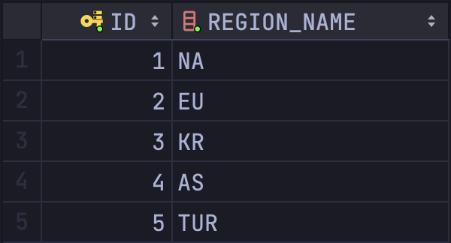

TEAMS

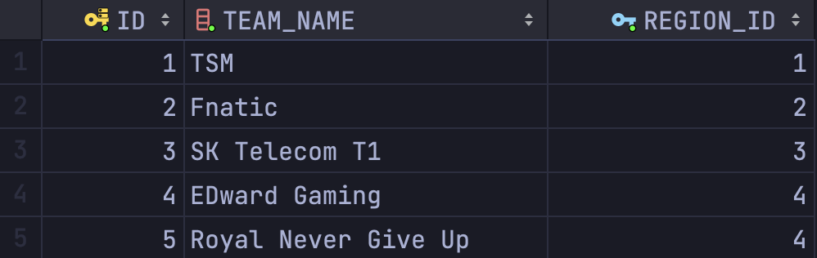

ROLES

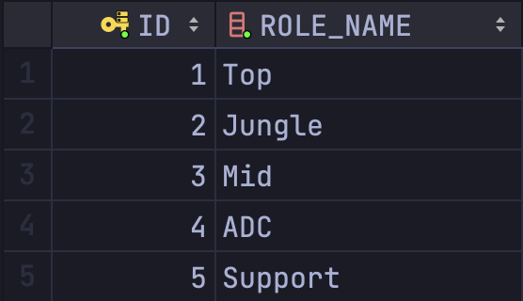

PLAYERS

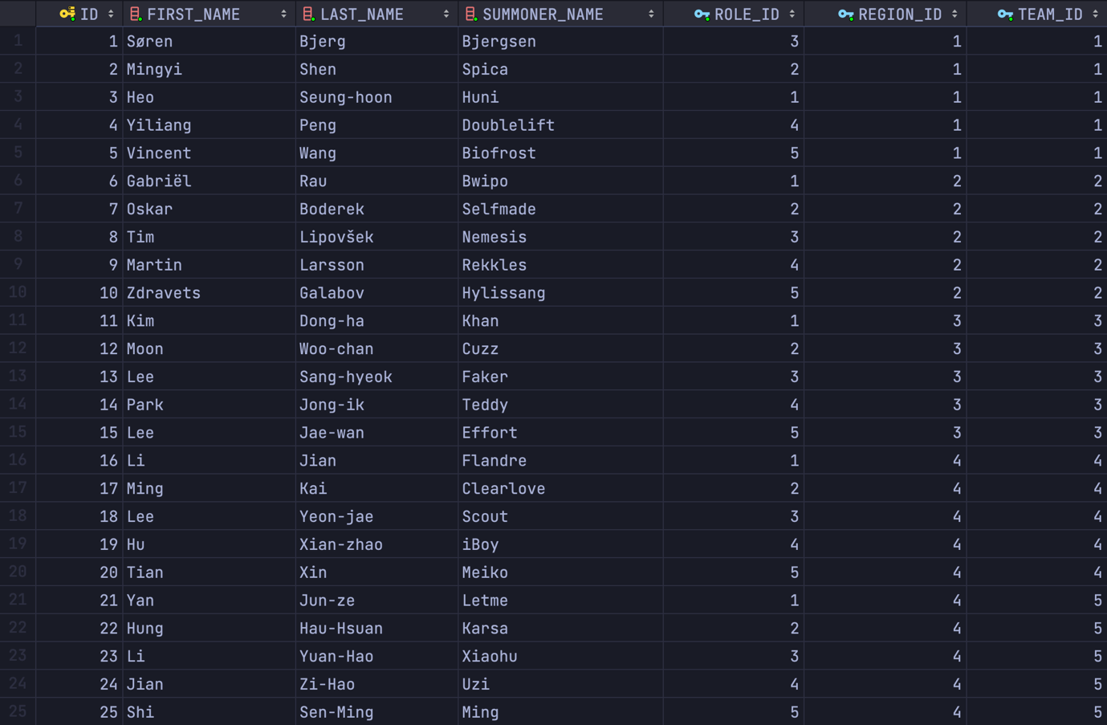

TOURNAMENTS

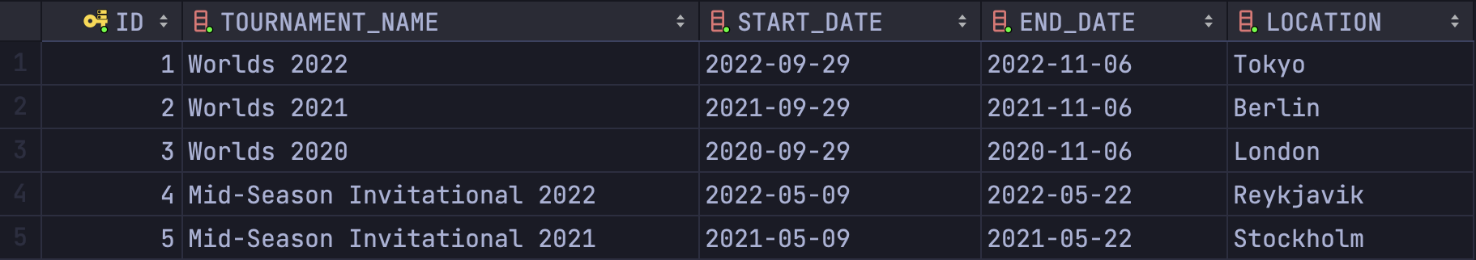

MATCHES

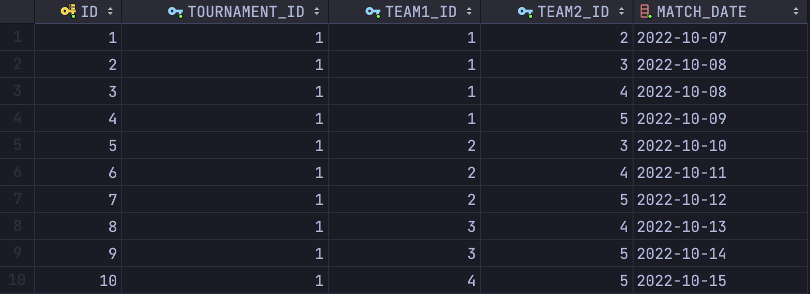

MATCH_RESULTS

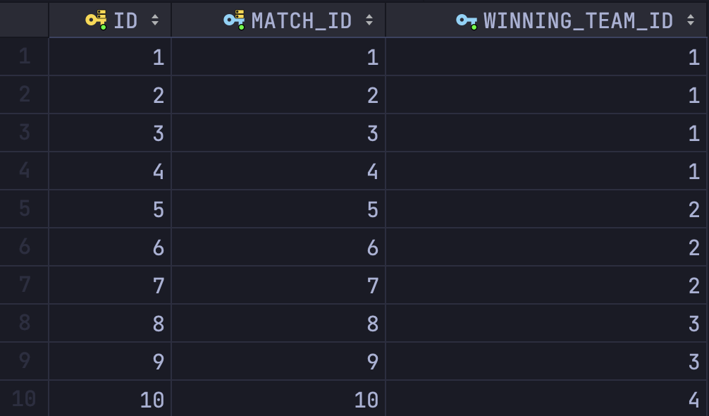

PLAYER_STATISTICS (nu toate, sunt 100 de date inserate)

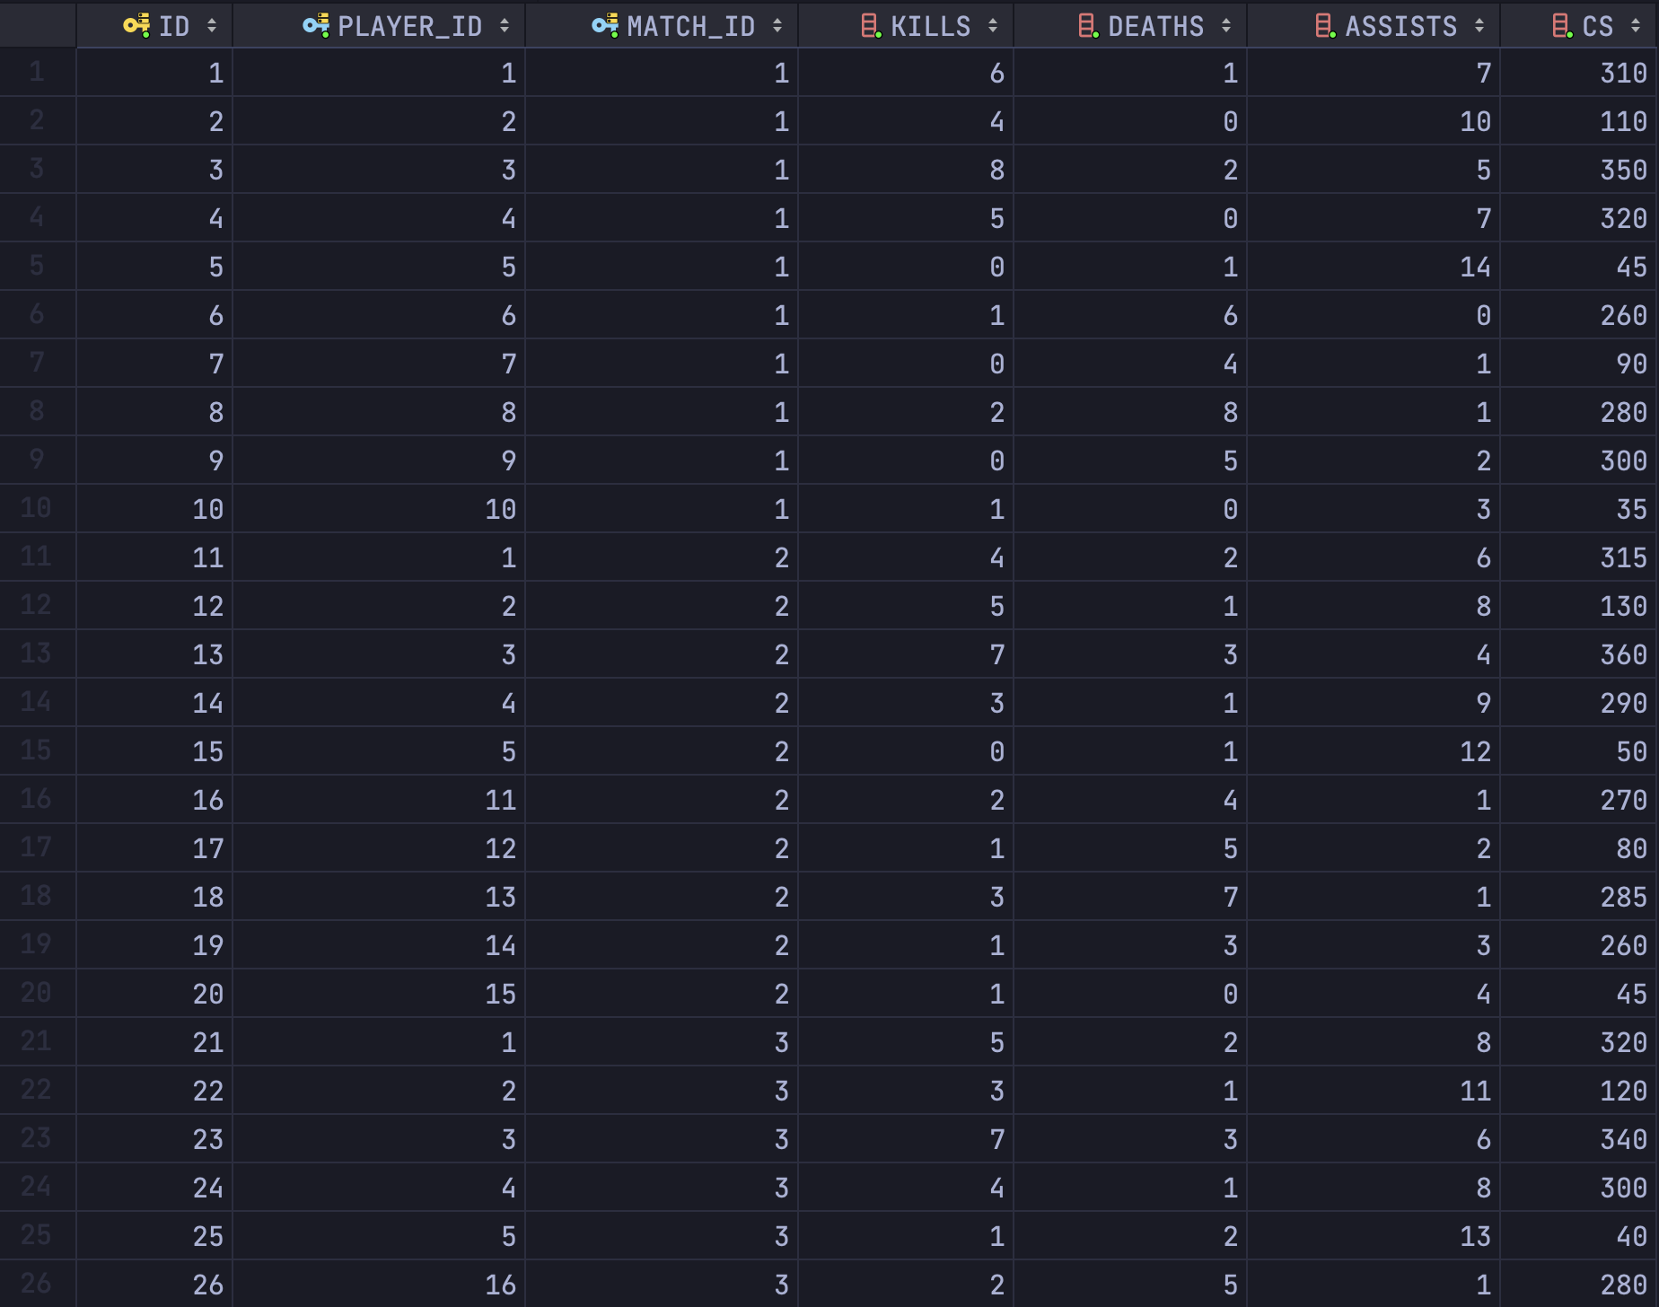

CHAMPIONS

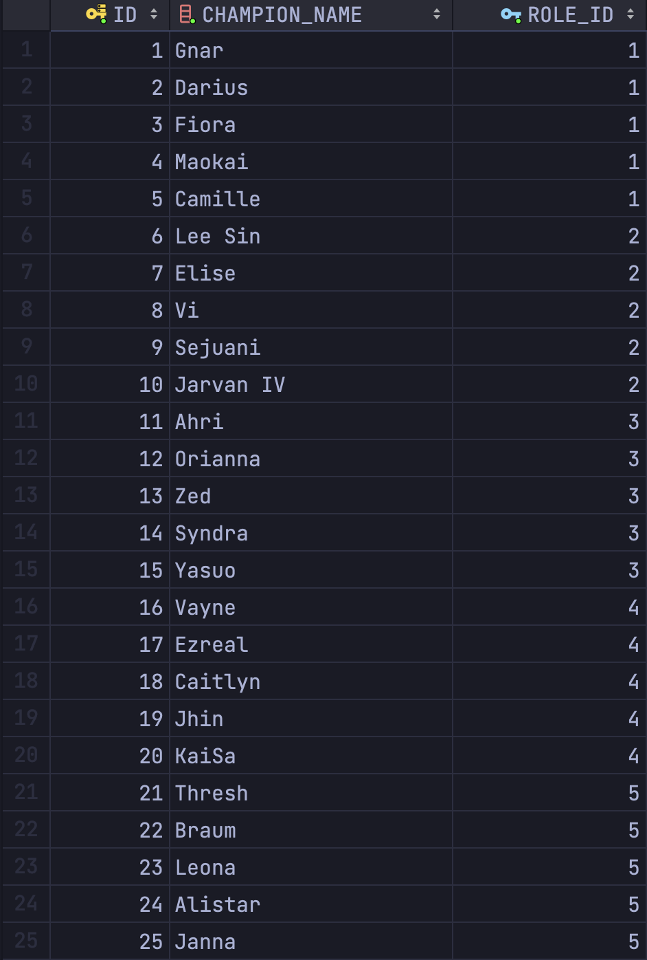

CHAMPION_PICKS (nu toate, sunt 100 de date inserate)

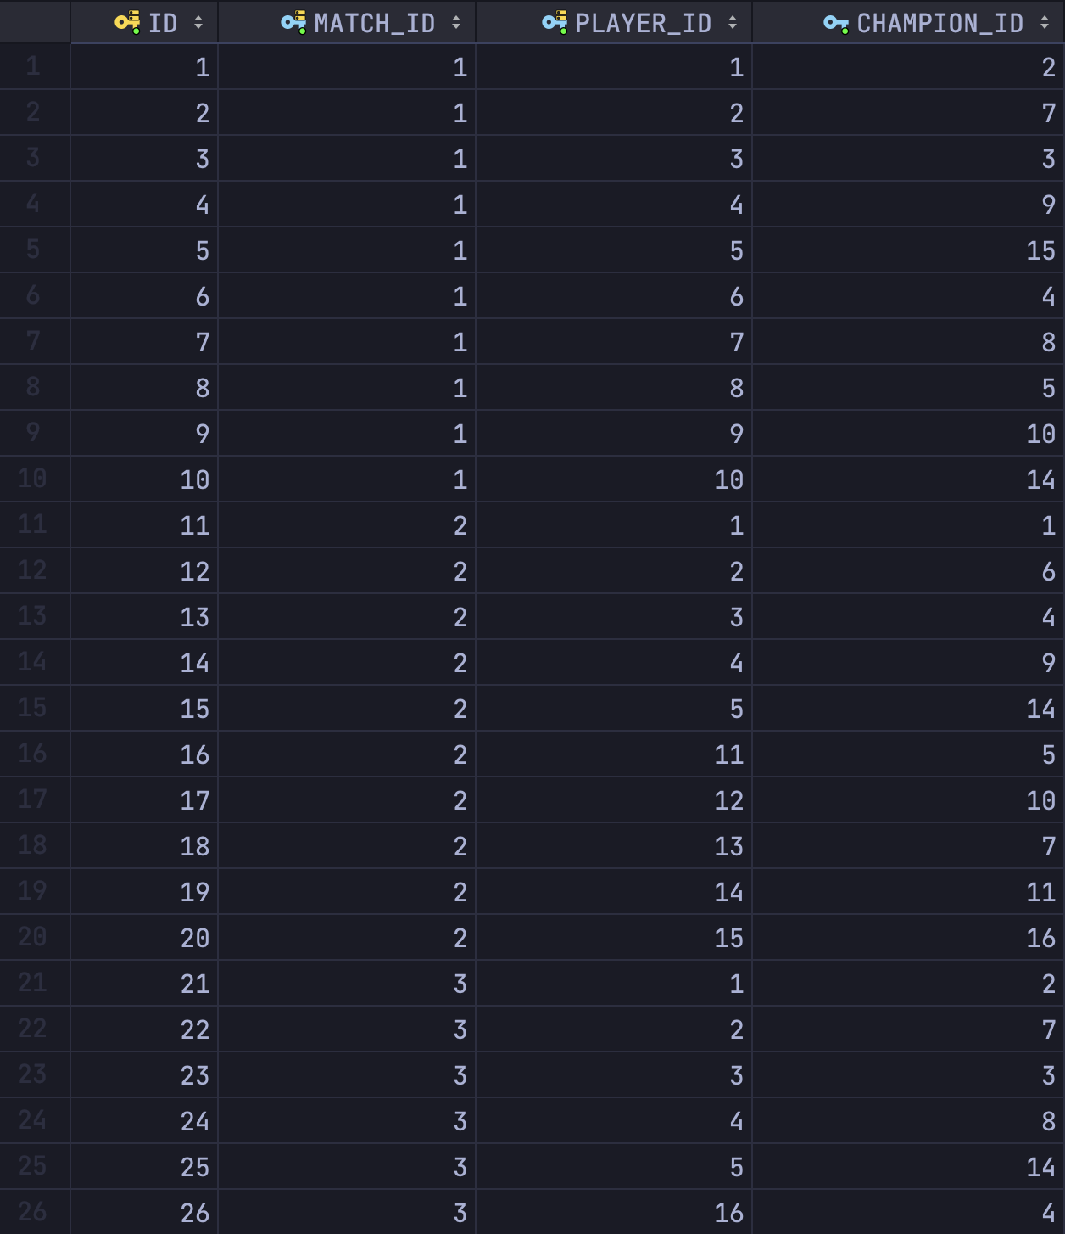

BANS

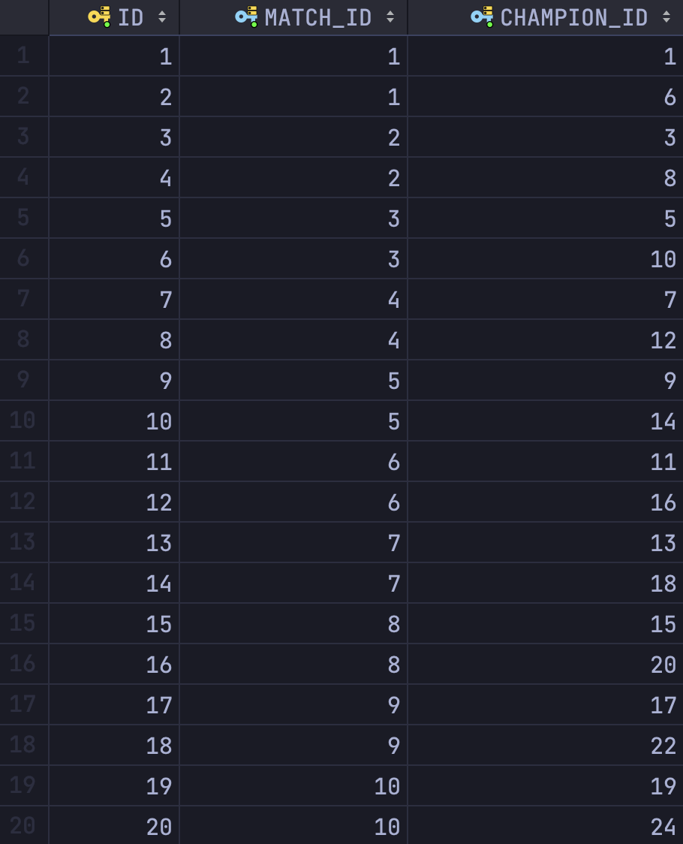

## Subprogram stocat cu minim doua tipuri de colectii

-- Pentru un turneu dat, pentru fiecare rol, sa se afiseze id-ul jucatorului ce joaca acel rol si are numarul maxim de kill-uri facute de acesta intr-un singur meci. Afisati si numarul de killuri.

*CREATE OR REPLACE PROCEDURE ex6*(**p_tournament_name** *IN* tournaments.tournament_name%*TYPE*) *AS  
 TYPE* t_role_kills *IS TABLE OF NUMBER INDEX BY PLS_INTEGER*;  
 *TYPE* t_role_players *IS TABLE OF NUMBER INDEX BY PLS_INTEGER*;  
 *TYPE* t_result *IS TABLE OF VARCHAR2*(100);  
 **v_result** t_result := t_result();  
 **v_role_kills** t_role_kills;  
 **v_role_players** t_role_players;  
 **v_max_kills** *NUMBER*;  
 **v_player_id** players.id%*TYPE*;  
 **v_role_id** *roles*.id%*TYPE*;  
 **v_tournament_id** tournaments.id%*TYPE*;  
*BEGIN  
 SELECT id INTO* **v_tournament_id** *FROM* tournaments *WHERE* tournament_name = **p_tournament_name**;  
  
 *FOR* **r** *IN* (*SELECT id FROM roles*)  
 *LOOP* **v_role_id** := **r**.id;  
 *SELECT* **ps**.player_id, *MAX*(**ps**.kills)  
 *INTO* **v_player_id**, **v_max_kills** *FROM* player_statistics **ps** *JOIN* matches **m** *ON* **m**.id = **ps**.match_id  
 *JOIN* players **p** *ON* **p**.id = **ps**.player_id  
 *WHERE* **m**.tournament_id = **v_tournament_id** *AND* **p**.role_id = **v_role_id** *GROUP BY* **ps**.player_id  
 *ORDER BY MAX*(**ps**.kills) *DESC  
 FETCH FIRST ROW ONLY*;  
  
 *IF* **v_role_kills**.*EXISTS*(**v_role_id**) *THEN  
 IF* **v_max_kills** > **v_role_kills**(**v_role_id**) *THEN* **v_role_kills**(**v_role_id**) := **v_max_kills**;  
 **v_role_players**(**v_role_id**) := **v_player_id**;  
 *END IF*;  
 *ELSE* **v_role_kills**(**v_role_id**) := **v_max_kills**;  
 **v_role_players**(**v_role_id**) := **v_player_id**;  
 *END IF*;  
 *END LOOP*;  
  
 **v_role_id** := **v_role_kills**.first;  
 *WHILE* **v_role_id** *IS NOT NULL  
 LOOP* **v_result**.extend;  
 **v_result**(**v_result**.count) := 'Player with id ' || **v_role_players**(**v_role_id**) || ' in role ' || **v_role_id** ||  
 ' had the maximum kills: ' || **v_role_kills**(**v_role_id**);  
 **v_role_id** := **v_role_kills**.*next*(**v_role_id**);  
 *END LOOP*;  
  
 *FOR* **i** *IN* 1 .. **v_result**.count  
 *LOOP* dbms_output.*put_line*(**v_result**(**i**));  
 *END LOOP*;  
*END ex6*;  
/

Rulare:

*BEGIN  
 ex6*('Worlds 2022');  
*END*;  
/  
  
-- EXPECTED  
-- Player with id 3 in role 1 had the maximum kills: 8  
-- Player with id 2 in role 2 had the maximum kills: 6  
-- Player with id 8 in role 3 had the maximum kills: 8  
-- Player with id 4 in role 4 had the maximum kills: 5  
-- Player with id 15 in role 5 had the maximum kills: 1

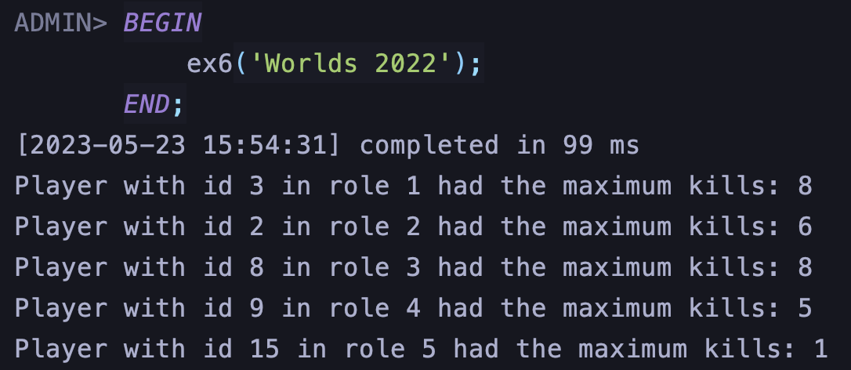

## Subprogram stocat cu doua tipuri de cursoare

-- Afișați numele echipelor și numărul de meciuri câștigate de acestea intr-un turneu dat.

*CREATE OR REPLACE PROCEDURE ex7*(**p_tournament_name** *IN* tournaments.tournament_name%*TYPE*)  
 *IS  
 CURSOR* c_teams  
 *IS  
 SELECT id*, team_name  
 *FROM* teams;  
 *TYPE* ref_cur_type *IS REF CURSOR*;  
 **v_team_wins** ref_cur_type;  
 **v_team_id** teams.id%*TYPE*;  
 **v_team_name** teams.team_name%*TYPE*;  
 **v_wins** *NUMBER*;  
 **v_tournament_id** tournaments.id%*TYPE*;  
*BEGIN  
 SELECT id INTO* **v_tournament_id** *FROM* tournaments *WHERE* tournament_name = **p_tournament_name**;  
  
 *OPEN* c_teams;  
 *LOOP  
 FETCH* c_teams *INTO* **v_team_id**, **v_team_name**;  
 *EXIT WHEN* c_teams%*NOTFOUND*;  
  
 *OPEN* **v_team_wins** *FOR  
 SELECT COUNT*(*) *AS* **wins** *FROM* match_results **mr** *JOIN* matches **m** *ON* **m**.id = **mr**.match_id  
 *WHERE* **m**.tournament_id = **v_tournament_id** *AND* **mr**.winning_team_id = **v_team_id**;  
  
 *FETCH* **v_team_wins** *INTO* **v_wins**;  
 *CLOSE* **v_team_wins**;  
  
 dbms_output.*put_line*('Team: ' || **v_team_name** || ' - Wins: ' || **v_wins**);  
 *END LOOP*;  
 *CLOSE* c_teams;  
*END ex7*;  
/

Rulare:

*BEGIN  
 ex7*('Worlds 2022');  
*END*;  
/  
  
-- EXPECTED  
-- Team: TSM - Wins: 4  
-- Team: Fnatic - Wins: 3  
-- Team: SK Telecom T1 - Wins: 2  
-- Team: EDward Gaming - Wins: 1  
-- Team: Royal Never Give Up - Wins: 0

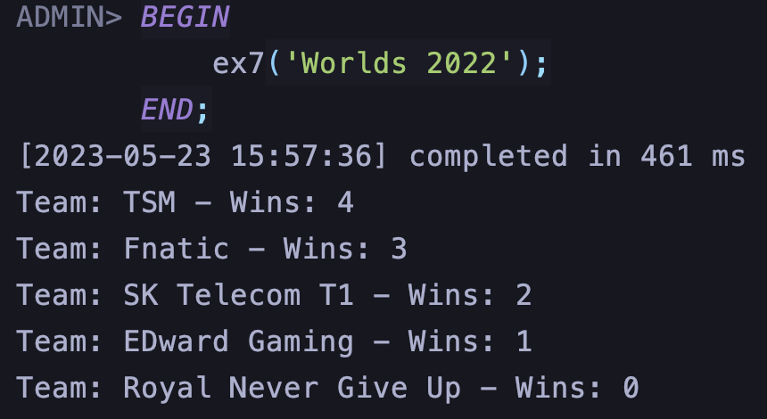

## Subprogram stocat de tip functie cu 3 tabele intr-o singura comanda si minim doua exceptii definite

-- Afisati numele jucatorilor care au un KDA mai mare decat media KDA-urilor tuturor jucatorilor dintr-un turneu dat.  
-- KDA = (kills + assists) / deaths, in cazul in care deaths = 0, KDA = kills + assists  
  
*CREATE OR REPLACE TYPE* players_table *IS TABLE OF VARCHAR2*(100);  
  
*CREATE OR REPLACE FUNCTION ex8*(**p_tournament_name** *IN* tournaments.tournament_name%*TYPE*)  
 *RETURN players_table IS* **v_kda_avg** *NUMBER*;  
 **v_player_name** *VARCHAR2*(100);  
 **v_player_kda** *NUMBER*;  
 **v_tournament_exists** *NUMBER*;  
 e_tournament_not_found *EXCEPTION*;  
 e_no_statistics_found *EXCEPTION*;  
 e_multiple_tournaments_found *EXCEPTION*;  
 **v_players_above_avg** *players_table* := *players_table*();  
 *CURSOR* c_kda_cursor *IS  
 SELECT* **p**.summoner_name,  
 (*SUM*(**ps**.kills) + *SUM*(**ps**.assists)) / (*NULLIF*(*SUM*(**ps**.deaths), 0)) *AS* **player_kda** *FROM* players **p** *JOIN* player_statistics **ps** *ON* **ps**.player_id = **p**.id  
 *JOIN* matches **m** *ON* **m**.id = **ps**.match_id  
 *JOIN* tournaments **t** *ON* **t**.id = **m**.tournament_id  
 *WHERE* **t**.tournament_name = **p_tournament_name** *GROUP BY* **p**.summoner_name;  
*BEGIN  
 SELECT COUNT*(*)  
 *INTO* **v_tournament_exists** *FROM* tournaments  
 *WHERE* tournament_name = **p_tournament_name**;  
  
 *IF* **v_tournament_exists** = 0 *THEN  
 RAISE* e_tournament_not_found;  
 *ELSIF* **v_tournament_exists** > 1 *THEN  
 RAISE* e_multiple_tournaments_found;  
 *END IF*;  
  
 *SELECT AVG*((**ps**.kills + **ps**.assists) / *NULLIF*(**ps**.deaths, 0))  
 *INTO* **v_kda_avg** *FROM* players **p** *JOIN* player_statistics **ps** *ON* **ps**.player_id = **p**.id  
 *JOIN* matches **m** *ON* **m**.id = **ps**.match_id  
 *JOIN* tournaments **t** *ON* **t**.id = **m**.tournament_id  
 *WHERE* **t**.tournament_name = **p_tournament_name**;  
  
 *IF* **v_kda_avg** *IS NULL THEN  
 RAISE* e_no_statistics_found;  
 *END IF*;  
  
 *OPEN* c_kda_cursor;  
 *LOOP  
 FETCH* c_kda_cursor *INTO* **v_player_name**, **v_player_kda**;  
 *EXIT WHEN* c_kda_cursor%*NOTFOUND*;  
 *IF* **v_player_kda** > **v_kda_avg** *THEN* **v_players_above_avg**.extend;  
 **v_players_above_avg**(**v_players_above_avg**.count) := **v_player_name**;  
 *END IF*;  
 *END LOOP*;  
 *CLOSE* c_kda_cursor;  
  
 *RETURN* **v_players_above_avg**;  
  
*EXCEPTION  
 WHEN* e_no_statistics_found *THEN  
 RAISE_APPLICATION_ERROR*(-20001, 'No statistics found for tournament ' || **p_tournament_name** || '.');  
 *RETURN NULL*;  
 *WHEN* e_multiple_tournaments_found *THEN  
 RAISE_APPLICATION_ERROR*(-20002,  
 'Multiple tournaments found with name ' || **p_tournament_name** || '.');  
 *RETURN NULL*;  
 *WHEN* e_tournament_not_found *THEN  
 RAISE_APPLICATION_ERROR*(-20003, 'Tournament with name ' || **p_tournament_name** || ' does not exist.');  
 *RETURN NULL*;  
*END ex8*;  
/

Rulare:

*DECLARE* **players** *players_table*;  
*BEGIN* **players** := *ex8*('Worlds 2022');  
 *FOR* **i** *IN* 1..**players**.count  
 *LOOP* dbms_output.*put_line*(**players**(**i**));  
 *END LOOP*;  
*END*;  
/  
  
-- EXPECTED  
-- Spica  
-- Doublelift  
-- Ming  
-- Bjergsen  
-- Hylissang  
-- Effort  
-- Meiko  
-- Biofrost  
-- Selfmade

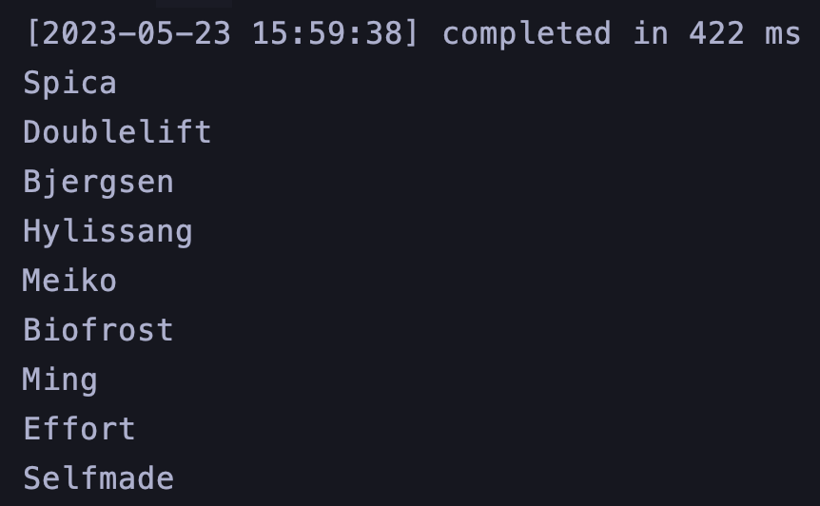

*DECLARE* **players** *players_table*;  
*BEGIN* **players** := *ex8*('Worlds 2021');  
 *FOR* **i** *IN* 1..**players**.count  
 *LOOP* dbms_output.*put_line*(**players**(**i**));  
 *END LOOP*;  
*END*;  
/  
  
-- EXPECTED  
-- No statistics found for tournament Worlds 2021.

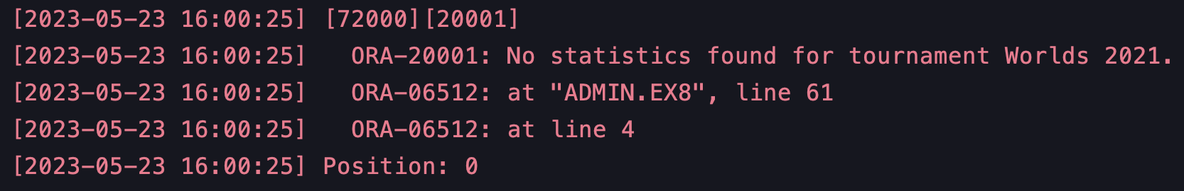

-- Cream un turneu cu un nume ce este deja prezent in baza de date  
-- pentru a testa exceptia multiple_tournaments_found.  
  
*INSERT INTO* tournaments (tournament_name, start_date, end_date, *location*, *id*)  
*VALUES* ('Worlds 2020', *TO_DATE*('2020-09-29', 'YYYY-MM-DD'), *TO_DATE*('2020-11-06', 'YYYY-MM-DD'), 'London', 999);  
*COMMIT*;  
  
*DECLARE* **players** *players_table*;  
*BEGIN* **players** := *ex8*('Worlds 2020');  
 *FOR* **i** *IN* 1..**players**.count  
 *LOOP* dbms_output.*put_line*(**players**(**i**));  
 *END LOOP*;  
*END*;  
/  
  
-- EXPECTED  
-- Multiple tournaments found with name Worlds 2020.  
  
-- Stergem turneul creat anterior.  
*DELETE  
FROM* tournaments  
*WHERE id* = 999;

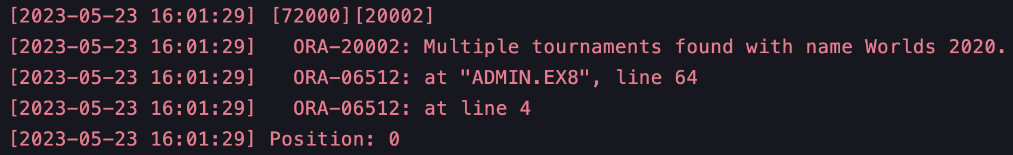

*DECLARE* **players** *players_table*;  
*BEGIN* **players** := *ex8*('BadName');  
 *FOR* **i** *IN* 1..**players**.count  
 *LOOP* dbms_output.*put_line*(**players**(**i**));  
 *END LOOP*;  
*END*;  
/  
  
-- EXPECTED  
-- Tournament with name BadName does not exist.

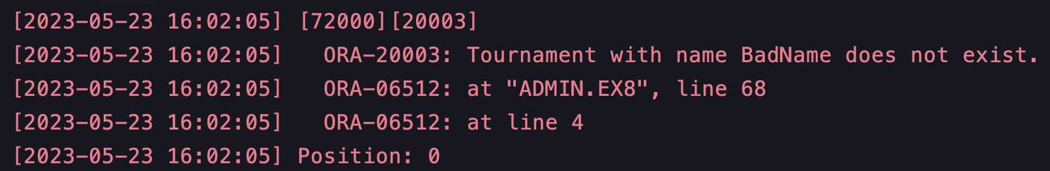

## Subprogram stocat cu 5 tabele intr-o singura comanda si exceptiile no_data_found si too_many_rows tratate

-- Afisati numele campionilor si media de cs ce sunt in top 5 in functie de media de cs pe meci  
-- pentru un anumit turneu.  
  
*CREATE OR REPLACE PROCEDURE ex9*(**p_tournament_name** *IN* tournaments.tournament_name%*TYPE*)  
 *IS  
 TYPE* r_cs_champions_type *IS RECORD* (  
 champion_name champions.champion_name%*TYPE*,  
 average_cs *NUMBER* );  
 *TYPE* t_cs_champions_table *IS TABLE OF* r_cs_champions_type;  
 **v_cs_champions** t_cs_champions_table;  
 **v_tournament_exists** *NUMBER*;  
 *CURSOR* c_top5_avg *IS  
 SELECT* **c**.champion_name, *AVG*(**ps**.cs) *AS* **average_cs** *FROM* champions **c** *JOIN* champion_picks **cp** *ON* **c**.id = **cp**.champion_id  
 *JOIN* player_statistics **ps** *ON* **cp**.player_id = **ps**.player_id *AND* **cp**.match_id = **ps**.match_id  
 *JOIN* matches **m** *ON* **cp**.match_id = **m**.id  
 *JOIN* tournaments **t** *ON* **m**.tournament_id = **t**.id  
 *WHERE* **t**.tournament_name = **p_tournament_name** *GROUP BY* **c**.champion_name  
 *HAVING AVG*(**ps**.cs) > 250  
 *ORDER BY AVG*(**ps**.cs) *DESC*;  
*BEGIN  
 SELECT id INTO* **v_tournament_exists** *FROM* tournaments *WHERE* tournament_name = **p_tournament_name**;  
  
 *OPEN* c_top5_avg;  
 *FETCH* c_top5_avg *BULK COLLECT INTO* **v_cs_champions**;  
 *CLOSE* c_top5_avg;  
  
 *FOR* **i** *IN* 1..*LEAST*(**v_cs_champions**.count, 5)  
 *LOOP* dbms_output.*put_line*('Champion ' || **v_cs_champions**(**i**).champion_name || ' has an average CS of ' ||  
 *ROUND*(**v_cs_champions**(**i**).average_cs, 0));  
 *END LOOP*;  
*EXCEPTION  
 WHEN* no_data_found *THEN  
 RAISE_APPLICATION_ERROR*(-20001, 'Tournament with name ' || **p_tournament_name** || ' does not exist.');  
 *WHEN* too_many_rows *THEN  
 RAISE_APPLICATION_ERROR*(-20002, 'Multiple tournaments with name ' || **p_tournament_name** || ' exist.');  
*END ex9*;  
/

Rulare:

*BEGIN  
 ex9*('Worlds 2022');  
*END*;

/  
  
-- EXPECTED  
-- Champion Maokai has an average CS of 343  
-- Champion Fiora has an average CS of 322  
-- Champion Gnar has an average CS of 316  
-- Champion Camille has an average CS of 289  
-- Champion Ahri has an average CS of 283

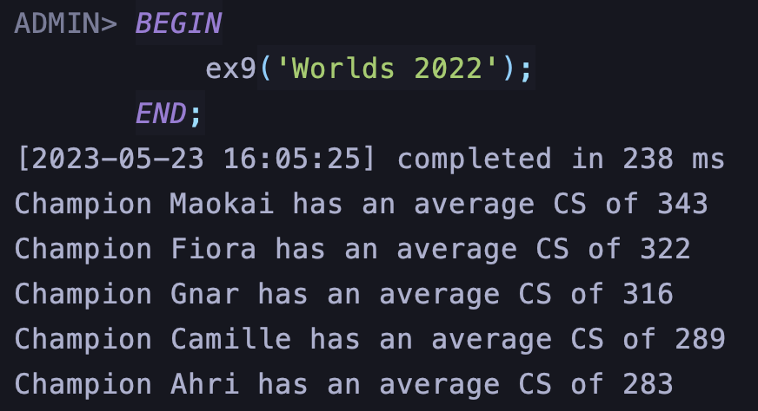

*BEGIN  
 ex9*('BadName');  
*END*;

/  
  
-- EXPECTED  
-- Tournament with name BadName does not exist.

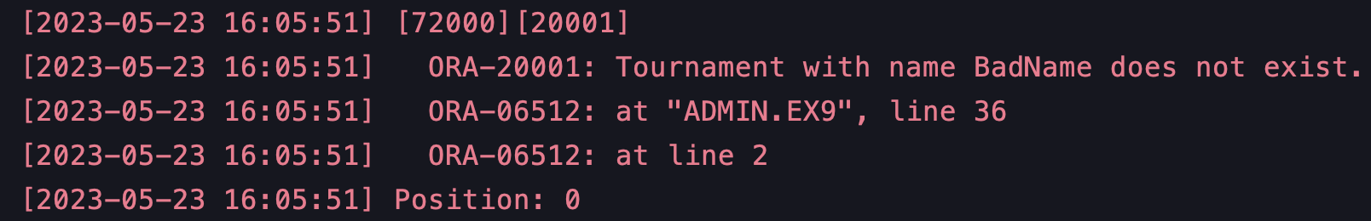

-- Cream un turneu cu un nume ce este deja prezent in baza de date  
-- pentru a testa exceptia multiple_tournaments_found.  
  
*INSERT INTO* tournaments (tournament_name, start_date, end_date, *location*, *id*)  
*VALUES* ('Worlds 2020', *TO_DATE*('2020-09-29', 'YYYY-MM-DD'), *TO_DATE*('2020-11-06', 'YYYY-MM-DD'), 'London', 999);  
*COMMIT*;  
  
*BEGIN  
 ex9*('Worlds 2020');  
*END*;  
  
-- EXPECTED  
-- Multiple tournaments with name Worlds 2020 exist.  
  
-- Stergem turneul creat anterior.  
*DELETE  
FROM* tournaments  
*WHERE id* = 999;

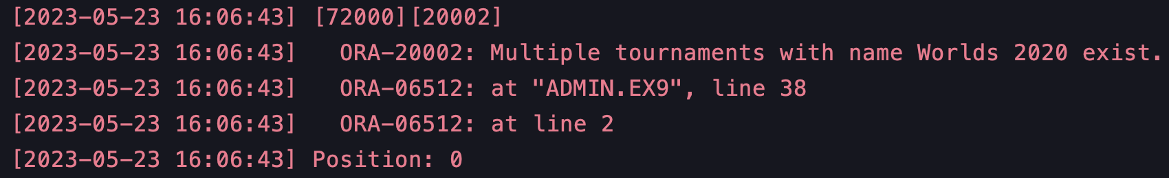

## Trigger de tip LMD la nivel de comanda

-- Acest trigger se asigura de faptul ca nu se pot actualiza sau sterge date din tabela regions.  
  
*CREATE OR REPLACE TRIGGER* trigger_ex10  
 *BEFORE UPDATE OR DELETE  
 ON* regions  
*BEGIN  
 IF UPDATING THEN  
 RAISE_APPLICATION_ERROR*(-20001, 'Regions cannot be updated');  
 *ELSIF DELETING THEN  
 RAISE_APPLICATION_ERROR*(-20002, 'Regions cannot be deleted');  
 *END IF*;  
*END*;

/

Rulare:

*UPDATE* regions *SET* region_name = 'Europe' *WHERE id* = 1;  
-- EXPECTED:  
-- ORA-20001: Regions cannot be updated

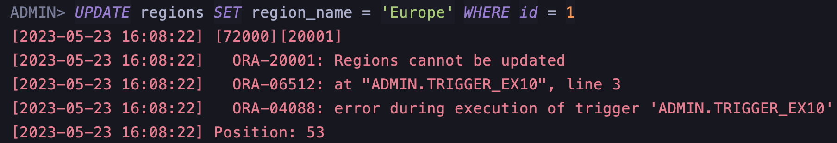

*DELETE FROM* regions *WHERE id* = 1;  
-- EXPECTED:  
-- ORA-20002: Regions cannot be deleted

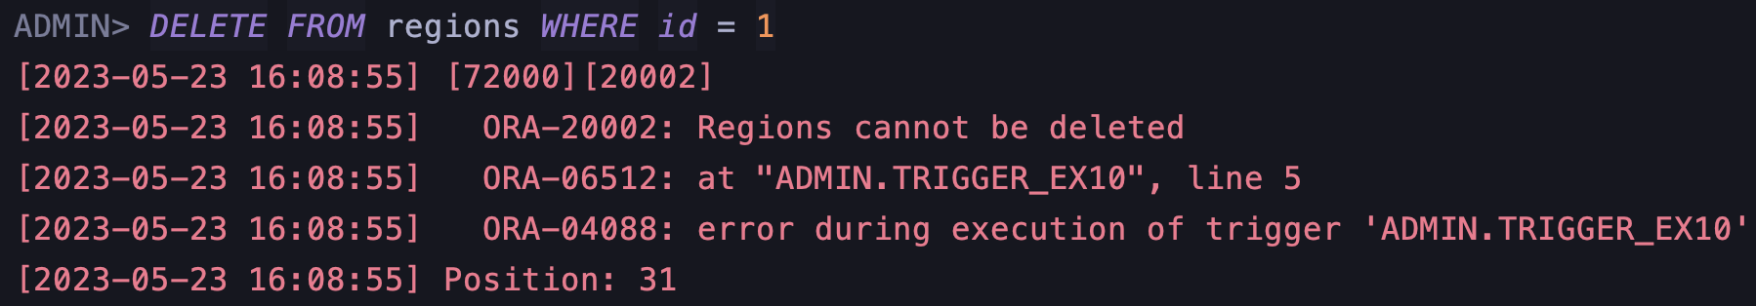

## Trigger de tip LMD la nivel de linie

-- Acest trigger se asigura de faptul ca la inserarea sau actualizarea datelor din tabela match_result,  
-- echipa castigatoare este una dintre cele doua echipe care au jucat meciul respectiv.  
  
*CREATE OR REPLACE TRIGGER* trigger_ex11  
 *BEFORE INSERT OR UPDATE  
 ON* match_results  
 *FOR EACH ROW  
DECLARE* **v_team1_id** teams.id%*TYPE*;  
 **v_team2_id** teams.id%*TYPE*;  
*BEGIN  
 SELECT* team1_id, team2_id *INTO* **v_team1_id**, **v_team2_id** *FROM* matches *WHERE id* = :**new**.match_id;  
  
 *IF* (:**new**.winning_team_id <> **v_team1_id** *AND* :**new**.winning_team_id <> **v_team2_id**) *THEN  
 RAISE_APPLICATION_ERROR*(-20001, 'Team ' || :**new**.winning_team_id || ' is not in match ' || :**new**.match_id);  
 *END IF*;  
*END*;

/

Rulare:

*INSERT INTO* match_results (match_id, winning_team_id)  
*VALUES* (1, 6);  
-- EXPECTED:  
-- ORA-20001: Team 6 is not in match 1

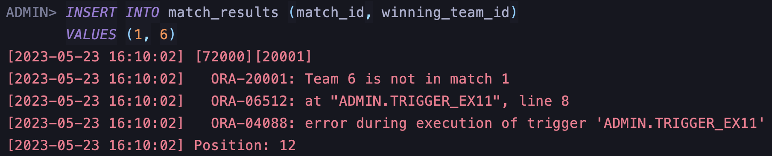

*INSERT INTO* match_results (match_id, winning_team_id)  
*VALUES* (28, 6);  
-- EXPECTED:  
-- ORA-01403: no data found

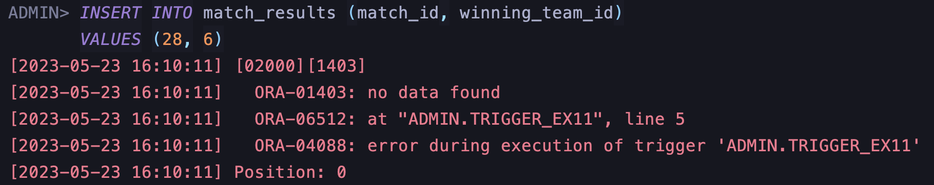

## Trigger de tip LDD

-- Acest trigger se asigura de faptul ca doar userul ADMIN poate crea, sterge sau modifica tabele.  
  
*CREATE OR REPLACE TRIGGER* trigger_ex12  
 *BEFORE CREATE OR DROP OR ALTER  
 ON SCHEMA  
BEGIN  
 IF* (*sys*.*login_user*() <> 'ADMIN') *THEN  
 RAISE_APPLICATION_ERROR*(-20001, 'Only ADMIN user can create, drop or alter tables');  
 *END IF*;  
*END*;

/

Rulare:

-- Pentru a testa acest trigger, trebuie sa va logati cu un user care nu este ADMIN.  
-- Pentru simplitate la rulare voi schimba conditia ca userul logat sa fie ADMIN2 pentru a declansa exceptia.  
  
*CREATE TABLE* test_table (*id NUMBER*);  
-- DROP TABLE test_table;  
  
-- EXPECTED:  
-- ORA-20001: Only ADMIN user can create, drop or alter tables

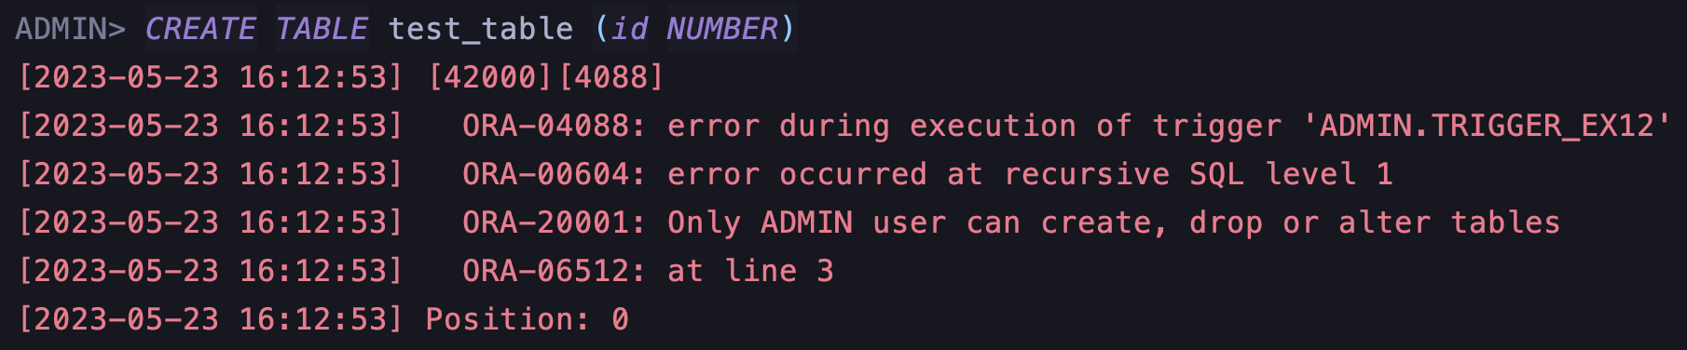

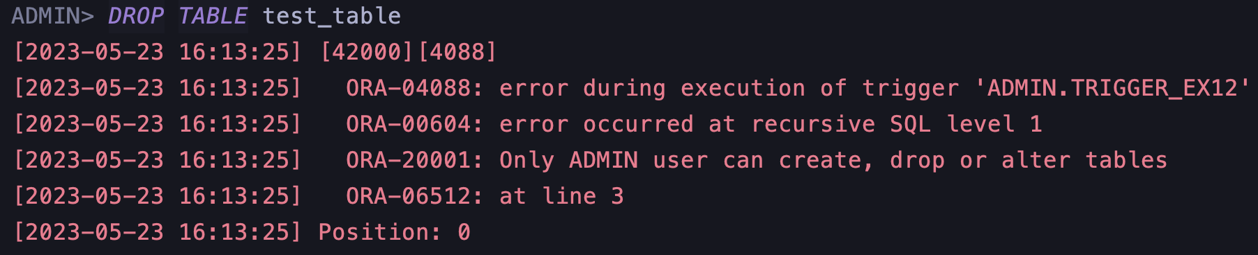

## Pachet cu obiectele realizate in cadrul proiectului

*CREATE OR REPLACE PACKAGE* package_ex13 *AS  
  
 TYPE* players_table_package *IS TABLE OF VARCHAR2*(100);  
 *PROCEDURE ex6*(**p_tournament_name** *IN* tournaments.tournament_name%*TYPE*);  
 *PROCEDURE ex7*(**p_tournament_name** *IN* tournaments.tournament_name%*TYPE*);  
 *FUNCTION ex8*(**p_tournament_name** *IN* tournaments.tournament_name%*TYPE*) *RETURN* players_table_package;  
 *PROCEDURE ex9*(**p_tournament_name** *IN* tournaments.tournament_name%*TYPE*);  
  
*END* package_ex13;  
/  
  
*CREATE OR REPLACE PACKAGE BODY* package_ex13 *AS* -- Pentru un turneu dat, pentru fiecare rol, sa se afiseze id-ul jucatorului ce joaca acel rol  
 -- si are numarul maxim de kill-uri facute de acesta intr-un singur meci. Afisati si numarul de killuri.  
 *PROCEDURE ex6*(**p_tournament_name** *IN* tournaments.tournament_name%*TYPE*) *AS  
 TYPE* t_role_kills *IS TABLE OF NUMBER INDEX BY PLS_INTEGER*;  
 *TYPE* t_role_players *IS TABLE OF NUMBER INDEX BY PLS_INTEGER*;  
 *TYPE* t_result *IS TABLE OF VARCHAR2*(100);  
 **v_result** t_result := t_result();  
 **v_role_kills** t_role_kills;  
 **v_role_players** t_role_players;  
 **v_max_kills** *NUMBER*;  
 **v_player_id** players.id%*TYPE*;  
 **v_role_id** *roles*.id%*TYPE*;  
 **v_tournament_id** tournaments.id%*TYPE*;  
 *BEGIN  
 SELECT id INTO* **v_tournament_id** *FROM* tournaments *WHERE* tournament_name = **p_tournament_name**;  
  
 *FOR* **r** *IN* (*SELECT id FROM roles*)  
 *LOOP* **v_role_id** := **r**.id;  
 *SELECT* **ps**.player_id, *MAX*(**ps**.kills)  
 *INTO* **v_player_id**, **v_max_kills** *FROM* player_statistics **ps** *JOIN* matches **m** *ON* **m**.id = **ps**.match_id  
 *JOIN* players **p** *ON* **p**.id = **ps**.player_id  
 *WHERE* **m**.tournament_id = **v_tournament_id** *AND* **p**.role_id = **v_role_id** *GROUP BY* **ps**.player_id  
 *ORDER BY MAX*(**ps**.kills) *DESC  
 FETCH FIRST ROW ONLY*;  
  
 *IF* **v_role_kills**.*EXISTS*(**v_role_id**) *THEN  
 IF* **v_max_kills** > **v_role_kills**(**v_role_id**) *THEN* **v_role_kills**(**v_role_id**) := **v_max_kills**;  
 **v_role_players**(**v_role_id**) := **v_player_id**;  
 *END IF*;  
 *ELSE* **v_role_kills**(**v_role_id**) := **v_max_kills**;  
 **v_role_players**(**v_role_id**) := **v_player_id**;  
 *END IF*;  
 *END LOOP*;  
  
 **v_role_id** := **v_role_kills**.first;  
 *WHILE* **v_role_id** *IS NOT NULL  
 LOOP* **v_result**.extend;  
 **v_result**(**v_result**.count) :=  
 'Player with id ' || **v_role_players**(**v_role_id**) || ' in role ' || **v_role_id** ||  
 ' had the maximum kills: ' || **v_role_kills**(**v_role_id**);  
 **v_role_id** := **v_role_kills**.*next*(**v_role_id**);  
 *END LOOP*;  
  
 *FOR* **i** *IN* 1 .. **v_result**.count  
 *LOOP* dbms_output.*put_line*(**v_result**(**i**));  
 *END LOOP*;  
 *END ex6*;  
  
 -- Afișați numele echipelor și numărul de meciuri câștigate de acestea intr-un turneu dat.  
 *PROCEDURE ex7*(**p_tournament_name** *IN* tournaments.tournament_name%*TYPE*)  
 *IS  
 CURSOR* c_teams  
 *IS  
 SELECT id*, team_name  
 *FROM* teams;  
 *TYPE* ref_cur_type *IS REF CURSOR*;  
 **v_team_wins** ref_cur_type;  
 **v_team_id** teams.id%*TYPE*;  
 **v_team_name** teams.team_name%*TYPE*;  
 **v_wins** *NUMBER*;  
 **v_tournament_id** tournaments.id%*TYPE*;  
 *BEGIN  
 SELECT id INTO* **v_tournament_id** *FROM* tournaments *WHERE* tournament_name = **p_tournament_name**;  
  
 *OPEN* c_teams;  
 *LOOP  
 FETCH* c_teams *INTO* **v_team_id**, **v_team_name**;  
 *EXIT WHEN* c_teams%*NOTFOUND*;  
  
 *OPEN* **v_team_wins** *FOR  
 SELECT COUNT*(*) *AS* **wins** *FROM* match_results **mr** *JOIN* matches **m** *ON* **m**.id = **mr**.match_id  
 *WHERE* **m**.tournament_id = **v_tournament_id** *AND* **mr**.winning_team_id = **v_team_id**;  
  
 *FETCH* **v_team_wins** *INTO* **v_wins**;  
 *CLOSE* **v_team_wins**;  
  
 dbms_output.*put_line*('Team: ' || **v_team_name** || ' - Wins: ' || **v_wins**);  
 *END LOOP*;  
 *CLOSE* c_teams;  
 *END ex7*;  
  
 -- Afisati numele jucatorilor care au un KDA mai mare decat media KDA-urilor tuturor jucatorilor dintr-un turneu dat.  
 -- KDA = (kills + assists) / deaths, in cazul in care deaths = 0, KDA = kills + assists  
 *FUNCTION ex8*(**p_tournament_name** *IN* tournaments.tournament_name%*TYPE*)  
 *RETURN players_table_package IS* **v_kda_avg** *NUMBER*;  
 **v_player_name** *VARCHAR2*(100);  
 **v_player_kda** *NUMBER*;  
 **v_tournament_exists** *NUMBER*;  
 e_tournament_not_found *EXCEPTION*;  
 e_no_statistics_found *EXCEPTION*;  
 e_multiple_tournaments_found *EXCEPTION*;  
 **v_players_above_avg** *players_table_package* := *players_table_package*();  
 *CURSOR* c_kda_cursor *IS  
 SELECT* **p**.summoner_name,  
 (*SUM*(**ps**.kills) + *SUM*(**ps**.assists)) / (*NULLIF*(*SUM*(**ps**.deaths), 0)) *AS* **player_kda** *FROM* players **p** *JOIN* player_statistics **ps** *ON* **ps**.player_id = **p**.id  
 *JOIN* matches **m** *ON* **m**.id = **ps**.match_id  
 *JOIN* tournaments **t** *ON* **t**.id = **m**.tournament_id  
 *WHERE* **t**.tournament_name = **p_tournament_name** *GROUP BY* **p**.summoner_name;  
 *BEGIN  
 SELECT COUNT*(*)  
 *INTO* **v_tournament_exists** *FROM* tournaments  
 *WHERE* tournament_name = **p_tournament_name**;  
  
 *IF* **v_tournament_exists** = 0 *THEN  
 RAISE* e_tournament_not_found;  
 *ELSIF* **v_tournament_exists** > 1 *THEN  
 RAISE* e_multiple_tournaments_found;  
 *END IF*;  
  
 *SELECT AVG*((**ps**.kills + **ps**.assists) / *NULLIF*(**ps**.deaths, 0))  
 *INTO* **v_kda_avg** *FROM* players **p** *JOIN* player_statistics **ps** *ON* **ps**.player_id = **p**.id  
 *JOIN* matches **m** *ON* **m**.id = **ps**.match_id  
 *JOIN* tournaments **t** *ON* **t**.id = **m**.tournament_id  
 *WHERE* **t**.tournament_name = **p_tournament_name**;  
  
 *IF* **v_kda_avg** *IS NULL THEN  
 RAISE* e_no_statistics_found;  
 *END IF*;  
  
 *OPEN* c_kda_cursor;  
 *LOOP  
 FETCH* c_kda_cursor *INTO* **v_player_name**, **v_player_kda**;  
 *EXIT WHEN* c_kda_cursor%*NOTFOUND*;  
 *IF* **v_player_kda** > **v_kda_avg** *THEN* **v_players_above_avg**.extend;  
 **v_players_above_avg**(**v_players_above_avg**.count) := **v_player_name**;  
 *END IF*;  
 *END LOOP*;  
 *CLOSE* c_kda_cursor;  
  
 *RETURN* **v_players_above_avg**;  
  
 *EXCEPTION  
 WHEN* e_no_statistics_found *THEN  
 RAISE_APPLICATION_ERROR*(-20001, 'No statistics found for tournament ' || **p_tournament_name** || '.');  
 *RETURN NULL*;  
 *WHEN* e_multiple_tournaments_found *THEN  
 RAISE_APPLICATION_ERROR*(-20002,  
 'Multiple tournaments found with name ' || **p_tournament_name** || '.');  
 *RETURN NULL*;  
 *WHEN* e_tournament_not_found *THEN  
 RAISE_APPLICATION_ERROR*(-20003, 'Tournament with name ' || **p_tournament_name** || ' does not exist.');  
 *RETURN NULL*;  
 *END ex8*;  
  
 -- Afisati numele campionilor si media de cs ce sunt in top 5 in functie de media de cs pe meci  
 -- pentru un anumit turneu.  
 *PROCEDURE ex9*(**p_tournament_name** *IN* tournaments.tournament_name%*TYPE*)  
 *IS  
 TYPE* r_cs_champions_type *IS RECORD* (  
 champion_name champions.champion_name%*TYPE*,  
 average_cs *NUMBER* );  
 *TYPE* t_cs_champions_table *IS TABLE OF* r_cs_champions_type;  
 **v_cs_champions** t_cs_champions_table;  
 **v_tournament_exists** *NUMBER*;  
 *CURSOR* c_top5_avg *IS  
 SELECT* **c**.champion_name, *AVG*(**ps**.cs) *AS* **average_cs** *FROM* champions **c** *JOIN* champion_picks **cp** *ON* **c**.id = **cp**.champion_id  
 *JOIN* player_statistics **ps** *ON* **cp**.player_id = **ps**.player_id *AND* **cp**.match_id = **ps**.match_id  
 *JOIN* matches **m** *ON* **cp**.match_id = **m**.id  
 *JOIN* tournaments **t** *ON* **m**.tournament_id = **t**.id  
 *WHERE* **t**.tournament_name = **p_tournament_name** *GROUP BY* **c**.champion_name  
 *HAVING AVG*(**ps**.cs) > 250  
 *ORDER BY AVG*(**ps**.cs) *DESC*;  
 *BEGIN  
 SELECT id INTO* **v_tournament_exists** *FROM* tournaments *WHERE* tournament_name = **p_tournament_name**;  
  
 *OPEN* c_top5_avg;  
 *FETCH* c_top5_avg *BULK COLLECT INTO* **v_cs_champions**;  
 *CLOSE* c_top5_avg;  
  
 *FOR* **i** *IN* 1..*LEAST*(**v_cs_champions**.count, 5)  
 *LOOP* dbms_output.*put_line*('Champion ' || **v_cs_champions**(**i**).champion_name || ' has an average CS of ' ||  
 *ROUND*(**v_cs_champions**(**i**).average_cs, 0));  
 *END LOOP*;  
 *EXCEPTION  
 WHEN* no_data_found *THEN  
 RAISE_APPLICATION_ERROR*(-20001, 'Tournament with name ' || **p_tournament_name** || ' does not exist.');  
 *WHEN* too_many_rows *THEN  
 RAISE_APPLICATION_ERROR*(-20002, 'Multiple tournaments with name ' || **p_tournament_name** || ' exist.');  
 *END ex9*;  
  
*END* package_ex13;  
/

Rulare:

*DECLARE* **players** package_ex13.*players_table_package*;  
*BEGIN* package_ex13.*ex6*('Worlds 2022');  
 package_ex13.*ex7*('Worlds 2022');  
 **players** := package_ex13.*ex8*('Worlds 2022');  
 *FOR* **i** *IN* 1..**players**.count  
 *LOOP* dbms_output.*put_line*(**players**(**i**));  
 *END LOOP*;  
 package_ex13.*ex9*('Worlds 2022');  
*END*;  
/

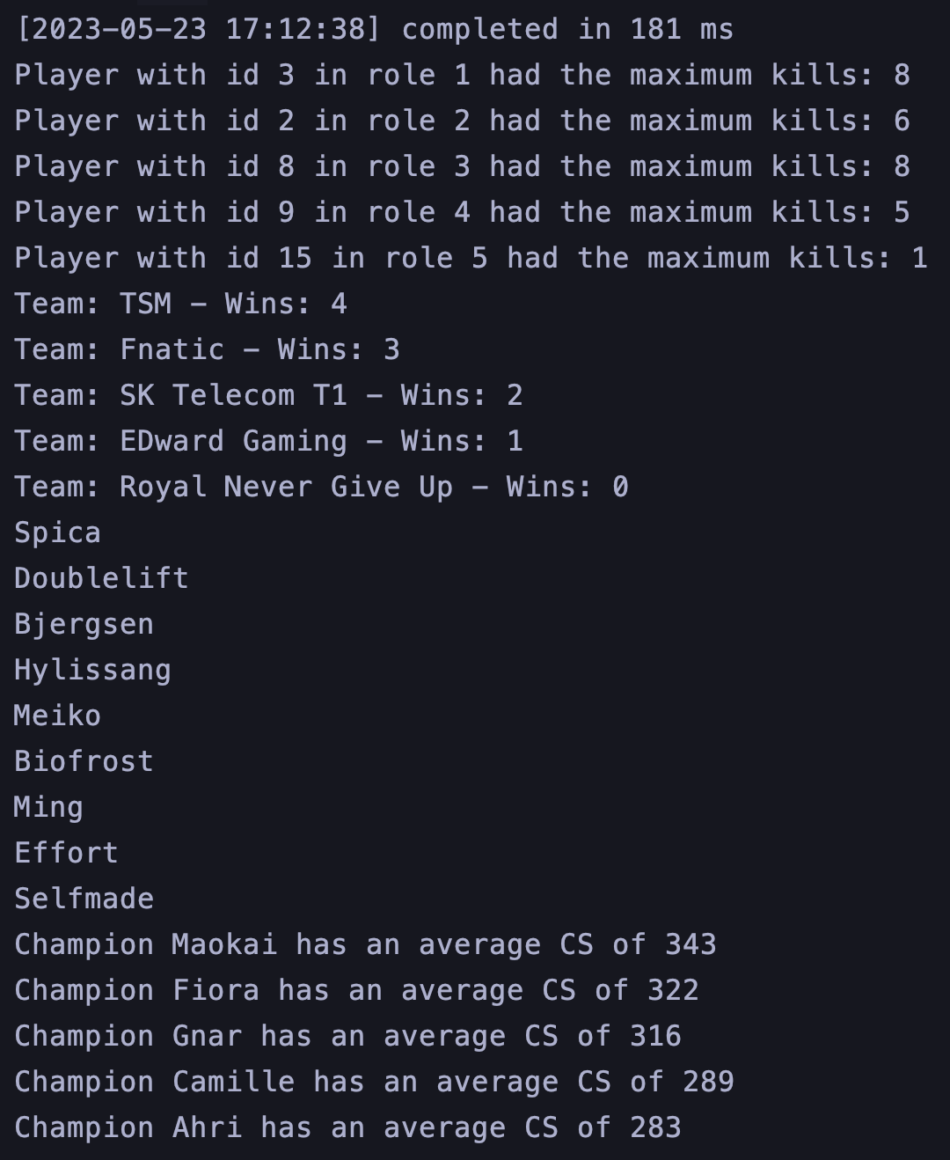

## Pachet cu flux de actiuni

-- Vrem sa aflam care este cel mai bun campion din meta intr-un turneu dat.  
-- Pentru a afla asta vom lua in considerare urmatoarele:  
-- 1. Numarul de banuri pe care il are campionul  
-- 2. Performanta campionului (KDA)  
-- Vom folosi urmatoarele formule:  
-- 1. Pentru numarul de banuri: bans_count * 100 / total_bans  
-- 2. Pentru performanta: (kills + assists) / deaths  
-- 3. Pentru scorul campionului: bans_score * 10 + performance * 5  
  
*CREATE OR REPLACE PACKAGE* package_ex14 *AS  
  
 TYPE* t_champion *IS RECORD* (  
 *id* champions.id%*TYPE*,  
 champion_name champions.champion_name%*TYPE*,  
 role_id champions.role_id%*TYPE*,  
 bans_count *NUMBER*,  
 bans_score *NUMBER*,  
 *performance NUMBER* );  
  
 *PROCEDURE parse_champion*(**p_champion_id** *IN NUMBER*, **p_tournament_id** *IN NUMBER*, **t_champion** *OUT* t_champion);  
  
 *PROCEDURE calculate_champion_performance*(**p_champion** *IN OUT* t_champion);  
  
 *FUNCTION calculate_meta_score*(**p_champion** *IN* t_champion) *RETURN NUMBER*;  
  
 *FUNCTION get_meta_champion*(**p_tournament_id** *IN NUMBER*) *RETURN* t_champion;  
  
*END* package_ex14;  
/  
  
*CREATE OR REPLACE PACKAGE BODY* package_ex14 *AS  
  
 PROCEDURE parse_champion*(**p_champion_id** *IN NUMBER*, **p_tournament_id** *IN NUMBER*, **t_champion** *OUT t_champion*) *IS* **v_total_bans** *NUMBER*;  
 **v_bans_count** *NUMBER*;  
 *BEGIN  
 SELECT COUNT*(*)  
 *INTO* **v_total_bans** *FROM* bans **b** *INNER JOIN* matches **m** *ON* **b**.match_id = **m**.id  
 *WHERE* **m**.tournament_id = **p_tournament_id**;  
  
 *SELECT COUNT*(*)  
 *INTO* **v_bans_count** *FROM* bans **b** *INNER JOIN* matches **m** *ON* **b**.match_id = **m**.id  
 *WHERE* **m**.tournament_id = **p_tournament_id** *AND* champion_id = **p_champion_id**;  
 **t_champion**.id := **p_champion_id**;  
  
 *SELECT* champion_name, role_id  
 *INTO* **t_champion**.champion_name, **t_champion**.role_id  
 *FROM* champions  
 *WHERE id* = **p_champion_id**;  
  
 **t_champion**.bans_score := (**v_bans_count** * 100) / **v_total_bans**;  
 *calculate_champion_performance*(**t_champion**);  
 *END parse_champion*;  
  
 *PROCEDURE calculate_champion_performance*(**p_champion** *IN OUT t_champion*) *IS  
 BEGIN  
 SELECT ROUND*(*AVG*((**ps**.kills + **ps**.assists) / *NULLIF*(**ps**.deaths, 0)), 3)  
 *INTO* **p_champion**.performance  
 *FROM* player_statistics **ps** *INNER JOIN* champion_picks **cp** *ON* **ps**.match_id = **cp**.match_id *AND* **ps**.player_id = **cp**.player_id  
 *WHERE* **cp**.champion_id = **p_champion**.id;  
 *END calculate_champion_performance*;  
  
 *FUNCTION calculate_meta_score*(**p_champion** *IN t_champion*) *RETURN NUMBER IS  
 BEGIN  
 RETURN* **p_champion**.bans_score * 10 + **p_champion**.performance * 5;  
 *END calculate_meta_score*;  
  
 *FUNCTION get_meta_champion*(**p_tournament_id** *IN NUMBER*) *RETURN t_champion IS* **v_best_champion** *t_champion*;  
 **v_current_champion** *t_champion*;  
 **v_best_score** *NUMBER* := 0;  
 **v_current_score** *NUMBER*;  
 e_no_champion_data_found *EXCEPTION*;  
 *CURSOR* c_champions_with_data *IS  
 SELECT id  
 FROM* champions  
 *WHERE* 0 < (*SELECT COUNT*(*)  
 *FROM* champion_picks  
 *WHERE* champion_id = champions.id  
 *AND* match_id *IN* (*SELECT id FROM* matches *WHERE* tournament_id = **p_tournament_id**))  
 *OR* 0 < (*SELECT COUNT*(*)  
 *FROM* bans  
 *WHERE* champion_id = champions.id  
 *AND* match_id *IN* (*SELECT id FROM* matches *WHERE* tournament_id = **p_tournament_id**));  
 *BEGIN  
 FOR* **r** *IN* c_champions_with_data  
 *LOOP  
 parse_champion*(**r**.id, **p_tournament_id**, **v_current_champion**);  
 **v_current_score** := *calculate_meta_score*(**v_current_champion**);  
 *IF* **v_current_score** > **v_best_score** *THEN* **v_best_score** := **v_current_score**;  
 **v_best_champion** := **v_current_champion**;  
 *END IF*;  
 *END LOOP*;  
 *IF* **v_best_champion**.id *is NULL THEN  
 RAISE* e_no_champion_data_found;  
 *END IF*;  
 *RETURN* **v_best_champion**;  
 *EXCEPTION  
 WHEN* e_no_champion_data_found *THEN  
 RAISE_APPLICATION_ERROR*(-20001, 'No champion data found for tournament with id ' || **p_tournament_id**);  
 *END get_meta_champion*;  
  
*END* package_ex14;  
/

Rulare:

*DECLARE* **v_meta_champion** package_ex14.*t_champion*;  
*BEGIN* **v_meta_champion** := package_ex14.*get_meta_champion*(1);  
 dbms_output.*put_line*('Meta champion is ' || **v_meta_champion**.champion_name || ' with a score of ' ||  
 **v_meta_champion**.performance);  
*END*;  
/  
  
-- EXPECTED:  
-- Meta champion is Yasuo with a score of 14

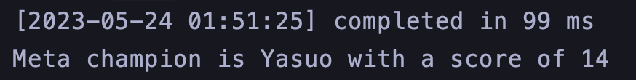

*DECLARE* **v_meta_champion** package_ex14.*t_champion*;  
*BEGIN* **v_meta_champion** := package_ex14.*get_meta_champion*(3);  
 dbms_output.*put_line*('Meta champion is ' || **v_meta_champion**.champion_name || ' with a score of ' ||  
 **v_meta_champion**.performance);  
*END*;  
/  
  
-- EXPECTED:  
-- ORA-20001: No champion data found for tournament with id 3

